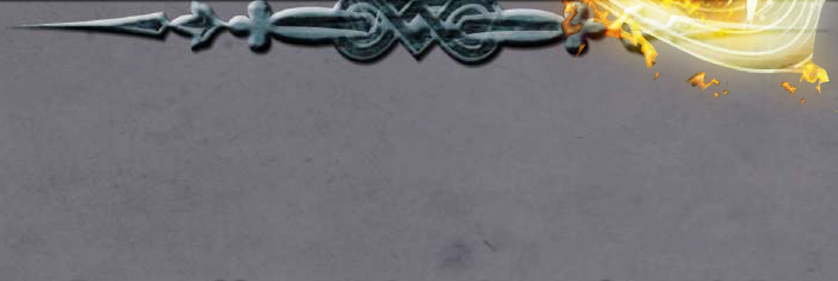

A collection of feats to aid your hero in facing challenges all around these (or any other) realms!

Well Met!

11 across the Realms, people live under many influences. Their faith dictates when and how they honor the gods, their heritage carries certain customs and beliefs, and their place in society can restrict rights or extend privileges.

However, there are few influences stronger than Faerun's regional cultures.

A stay in Waterdeep can see you blending into the melting pot of the community, and a visit to Tethyr might embroil you in courtly intrigue. And, while many don't agree with the beliefs and customs of the Wizards of Thay, you can't deny that their culture is a strong one.

Presented here is a volume of feats. Each entry details a selection of skills, fighting styles, or other abilities you might learn from the people of these places.

**A few things to remember:**

* **You do not need to be from a region to have learned their ways.**
* **You do not need to even be from the Forgotten Realms.**
* **Feats are an optional variant. Always consult with your DM when choosing feats.**

Grand cities like Waterdeep, Athkatla, Baldur's Gate, or Lyrabar are all places where your character could have learned any of these feats. That doesn't mean, however, that your character couldn't have picked up a few tips from traveling gypsies or merchants, on a journey, or even from an instructional manual they found

Credits



**Writing And Concept:** Biyan Holmes, James Capogna **Editing:** Rae Redford

**Additional Assistance:** Tara Holmes, Erik Beyer, Adrian Vail, Jason Beutler, Melissa Pillon

**ARTWORK CREDITS**

**Front Cover and page 22:** A derivative of "page 2, panel 1" from "Pepper & Carrot epl3 : The Pyjama Party" by David Revoy licensed under Creative Commons Attribution 4.0.

Change made: Crop and altered to fit with cover template. **Page** 1:

**Page 2:** City Night by Wizards of the Coast

**Page 3:** Arab Horse Soldiers by Guillaume Regamey, 1871 **Page 4:** 4e_mm_stone by Wizards of the Coast

**Page 5:** Casqui_digital_painting_HRoe_2008 by Heironymous Rowe, licensed under CC-SA 3.0

**Page 6:** Heroes (Bogatyri) by Viktor Mikhailovich Vasnetsov, 1881

**Page 7:** Town Night by Wizards of the Coast

**Page 8:** MonsterManual2_mudergoblin by Wizards of the Coast

**Page 9:** The Winged Horse by Mary Hamilton Frye, 1914 **Page 12:** The Duel by August von Pettenkofen, 1858

**Page 13:** Agrianian Peltast by Johnny Shumate, 2006, public domain

**Page 14:** MonsterManual3-woodelf by Wizards of the Coast **Page 16:** bookofviledarkness.iseeyou by Wizards of the Coast **Page 17:** Halfling Thief/Merchant by Daniel Comerci

**Page 18:** WotC-RacesOfStone-Contemplate by Wizards of the Coast

**Page 19:** bookofviledarkness.iseeyou by Wizards of the Coast **Back Cover:** ARCEMSPLASH by Jeff Brown

License

DUNGEONS & DRAGONS, D&D, Wizards of the Coast, Forgotten Realms, the dragon ampersand, Player’s Handbook, Monster Manual, Dungeon Master’s Guide, D&D Adventurers League, all other Wizards of the Coast product names, and their respective logos are trademarks of Wizards of the Coast in the USA and other countries. All characters and their distinctive likenesses are property of Wizards of the Coast. This material is protected under the copyright laws of the United States of America. Any reproduction or unauthorized use of the material or artwork contained herein is prohibited without the express written permission of Wizards of the Coast.

©2018 Wizards of the Coast LLC, PO Box 707, Renton, WA 98057-0707, USA Manufactured by Hasbro SA, Rue Emile-Boechat 31, 2800 Delemont, CH. Represented by Hasbro Europe, 4 The Square, Stockley Park, Uxbridge, Middlesex, UB11 1ET, UK.

This work contains material that is copyright Wizards of the Coast and/or other authors. Such material is used with permission under the Community Content Agreement for Dungeon Masters Guild

All other original material in this work is copyright 2018 by Bryan Holmes and published under the Community Content Agreement for Dungeon Masters Guild

The High Forest

The high forest is a mysterious and ancient wooded area, where the first elves laid their kingdoms. Later, liches from Netheril would settle here and fight with the denizens of the forest.

Spirit Caller

The Uthgardt Barbarians of the high forest have a deep respect for the woods, and many of them even have the ability to speak with the spirits of nature all around them.

Increase your Wisdom score by 1, to a maximum of 20.

Additionally, during a short rest, you choose one of the aspects of the world around you such as a rock or tree or stream. You may call upon the spirits of nature and speak to that aspect as though using the *Speak With Plants* spell upon that aspect.

As with the *Speak With Plants* spell, you may ask the aspect to perform some task at the DM's discretion. While you communicate as though you shared a language, you have no influence over the spirit.

The Frozenfar

The lands all surrounding Icewind Dale are generally referred to as the "Frozenfar". These harsh lands are home to giants, monsters, dwarves, and the last few points of light marking the edge of civilization.

Frontier Endurance

The people who choose to live in one of the most inhospitable lands in all of Faerun do so because they are tough and rugged From the people of the Ten Towns to the barbarians of the wilds, there are few as enduring as these souls.

The Silver Marches

From Neverwinter on the coast to the edge of the Anauroch desert in the east, the region is known for great heroes, dwarven exports, and elven artifacts.

Co-operative Combatant

Glorious Silverymoon, prosperous Neverwinter, and even smaller realms like Nesme are known for their cultural differences, but when push comes to shove they all consider each other allies when defending against the darkness.

When within 5 feet of at least one ally, you gain the following benefits:

* Advantage on opposed checks that use Strength, Dexterity, or Constitution.
* Advantage on saving throws or ability checks against effects or spells that would move you.
* Advantage on saving throws against spells or effects that cause fear.

Additionally, if you are within 5 feet of more than one ally, any of the checks made with Co-operative Combatant that you are proficient with have the bonus from proficiency doubled

The Sword Coast

Dangerous creatures, webs of intrigue, and high adventure await all those who call the sword coast home.

Ready For Anything

Those who call Waterdeep home are afforded the greatest exposure to different cultures, races, and aptitudes of all Faerun. Just when one thinks they've seen it all, Waterdeep comes up with the unexpected

Increase your Constitution score by 1, to a maximum of 20.

Additionally, you gain the following benefits:

Increase you Dexterity score by 1, to a maximum of 20.

Additionally, you have the following benefits:

Whenever you are forced to make a saving throw due to extreme cold or from a spell or effect which would give you a level of exhaustion, you have advantage on that saving throw.

Any survival checks made to return to the last place where you completed a long rest automatically succeed regardless of weather or magic.

Snow does not count as difficult terrain for you and any skill checks you make while interacting with icy terrain have advantage.

* Add your proficiency modifier to your initiative rolls.
* If you have not yet taken a turn in combat, your first d20 roll you make in combat has advantage.
* When not in combat you may double your proficiency bonus on one ability check. You must complete a short or long rest before you can use this ability again.



Long ago, a great calamity caused the anauroch desert to form, but now it’s has ecosystems and peoples that all depend upon it. Where some see a hostile unforgiving environment, others have found opportunities.

Desert Survivor

The human tribes known as the Bedine, the Asabi lizard creatures, and roaming bands of gnolls have all created solutions for fighting harsh environments.

Your Constitution score increases by 1, to a maximum of 20.

In addition, you gain the following benefits:

* Whenever you are forced to make a saving throw due to extreme heat, or from a spell or effect which would give you a level of exhaustion, you have advantage on that saving throw.
* Sandy or loose dirt and rock does not count as difficult terrain for you.
* You have advantage on any ability checks made with the Stealth skill in sandy areas or in deserts.
* You only need to eat and drink one quarter of what your race requires.

Bedine Cavalry Rider

Against the many goblin nations of the south, or the evil gnolls that dwell within their deserts, the Bedine have become impeccable combatants on horseback, although few outside their tribes have learned these techniques.

You gain the following benefits:

* Gain proficiency with Animal Handling and Vehicles (Land) if you are not already proficient with them.
* Any mounts you ride can use their action to make a single melee attack.
* If your mount strikes a foe, you have advantage to strike the same foe on your next attack. Likewise if you strike a foe, your mount has advantage to attack the same foe on their next attack.

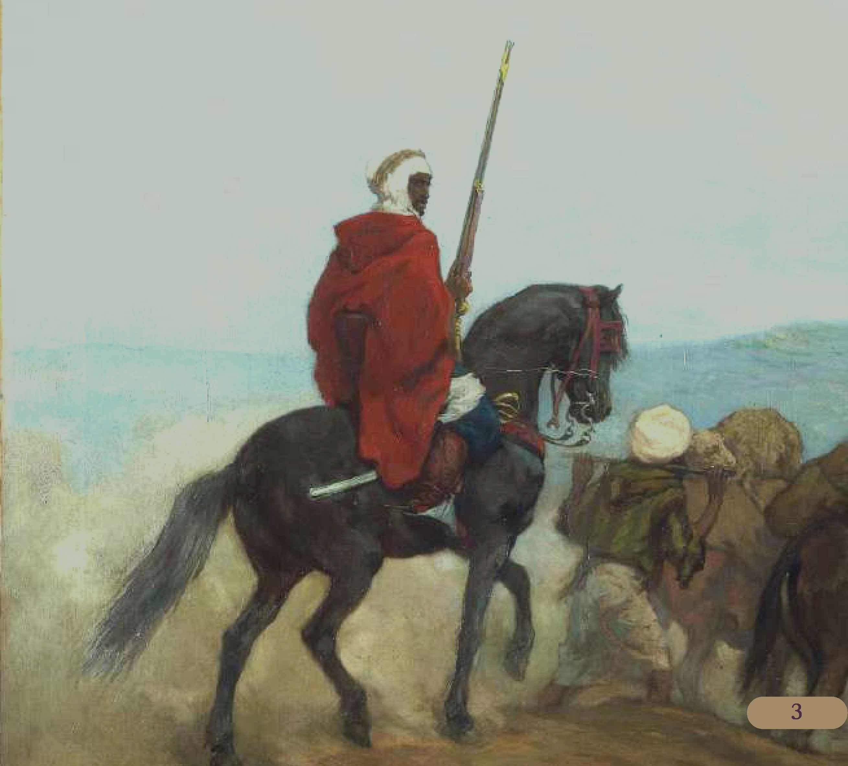

The handful of self-regulated domains known as ’’the Dales” are often considered the center of human civilization by many within the realms. While each dale does things differently from the last, they will always come to the needs of their neighbours.

Dalelands Forester

As much of the Dales are forested, many folks of these lands learn from an early age how to operate with respect to nature and the elves who make those forests their home.

Increase your Wisdom score by 1, to a maximum of 20.

Additionally, you gain the following benefits:

* You gain proficiency with all axes and woodcarvers tools.
* You double your proficiency when making skill checks that deal with identifying or crafting wood and when making survival or stealth checks while in wooded areas.
* You have advantage on any checks made to identify or track beasts.
* Treat your strength as 2 points higher for the purposes of lifting and carrying.

The Moonsea

The Moonsea is a region of cut-throats and merchants, all watching over their shoulders. The region is infamous for the being the homelands of the Zhentarim.

However, for someone looking to take a advantage of opportunities for themselves, the resources of the moonsea are like few others.

Paranoid Awareness

Your senses are honed to be aware of all the threats around you. Living where any day could be your last, save for a little bit of steel or magic, you’ve become quite good at staying one step ahead of death.

Increase your Wisdom score by 1, to a maximum of 20.

Additionally, you gain the following benefits:

* When making active opposed ability checks to detect lies or deceit, you have advantage on the rolls.
* You have advantage on saving throws against traps.
* If you are aware of the trap before it is set off, it has disadvantage when attacking you.

**Detecting Lies**

To maintain the illusion of a player not knowing if a NPC is lying or trying to deceive them, consider rolling advantage on their behalf.

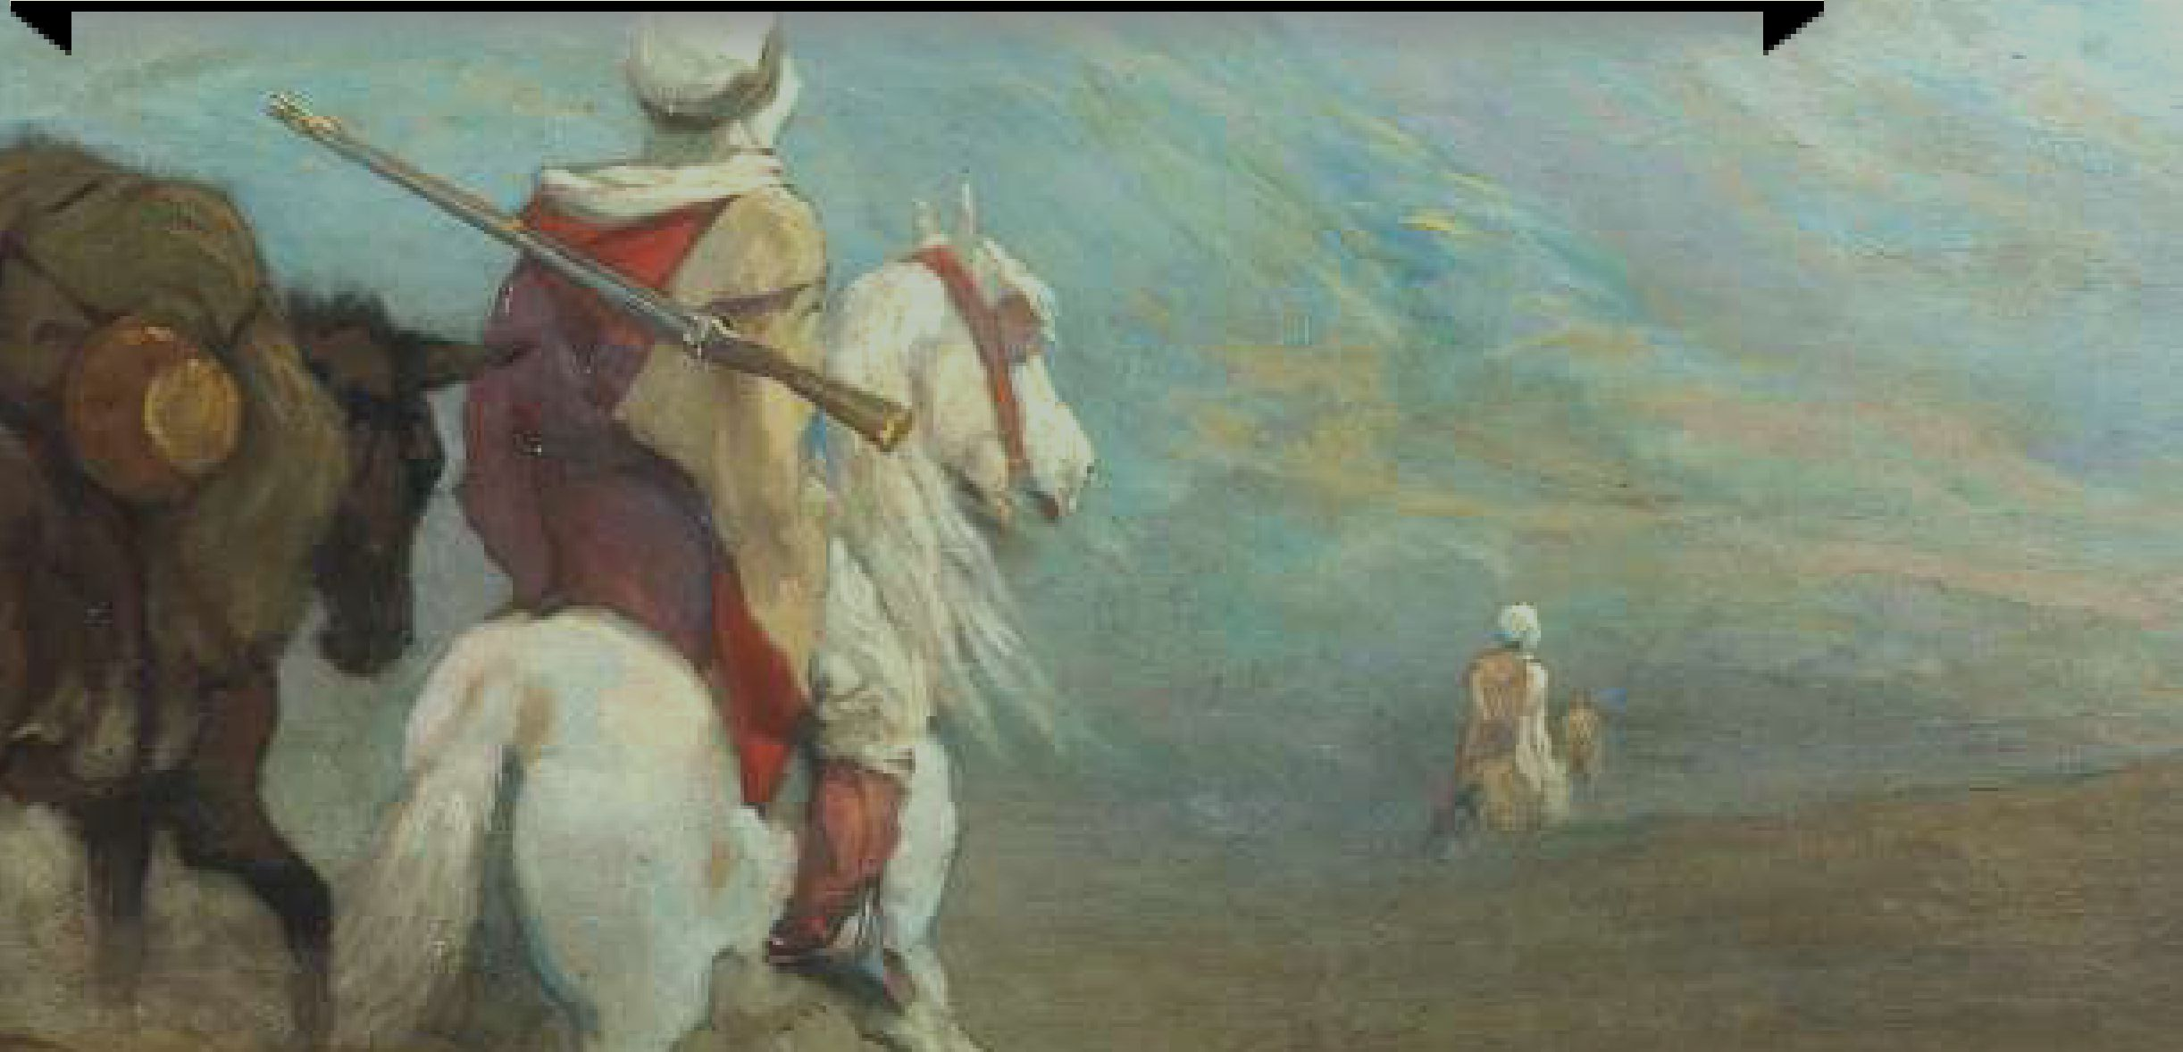

A region dotted with the many mines that keep the coffers of the Zhentarim and cities around the Moonsea region filled. It’s also home to a handful of barbarian tribes.

The Eraka are famous for their mounted troops, the Varm are known for totem magic and worshiping nature spirits, while the Vaegould are primordial cultists.

Eraka Horseriding

Although small, the nomadic Eraka tribes were famed for their ability to stave off Zhentil attackers from horseback. The Zhentarim soldiers reported back upon the danger of facing these foes on the open steppe.

While mounted, you gain the following benefits:

Having a strong connection to the primordials, the Varm are a peaceful tribe who tend to focus on the aspects of the world around them. They would not so much as set fire in the name of Kossuth, as they would thank him for granting them warmth.

As an action, you can summon an elemental It is a tiny creature crafted out of earth, water, fire, or air. You must possess at least two handfuls (or the equivalent amount) of appropriate material to summon this elemental For example, you might have a handful of grass you set on fire to summon a fire elemental or a bucket of water for a water elemental

The elemental is identical in ability to a Homunculus, but it is an elemental instead. Also replace the bite attack with one of the following abilities:

You gain +5 to initiative.

If either you or your mount are attacked, you may use your reaction to each take half the damage.

You have advantage on saving throws against spells or effects that would dismount you.

You have advantage on Animal Handling checks that target your mount.

**Fire.** Slam. *Melee Weapon Attack:* +4 to hit, reach 5 ft., one creature. *Hit.* Id4 fire damage. The target must succeed on a dexterity saving throw (DC 10) or ignite if they are flammable. A creature that is on fire takes ld4 fire damage at the start of each of their turns, until they use their action to put the flames out.

**Earth.** Slam. *Melee Weapon Attack:* +4 to hit, reach 5 ft., one creature. *Hit.* Id4 bludgeoning damage. The target must succeed on a strength saving throw (DC 10) or be knocked down.

**• Water.** Slam. *Melee Weapon Attack:* +4 to hit, reach 5 ft.,

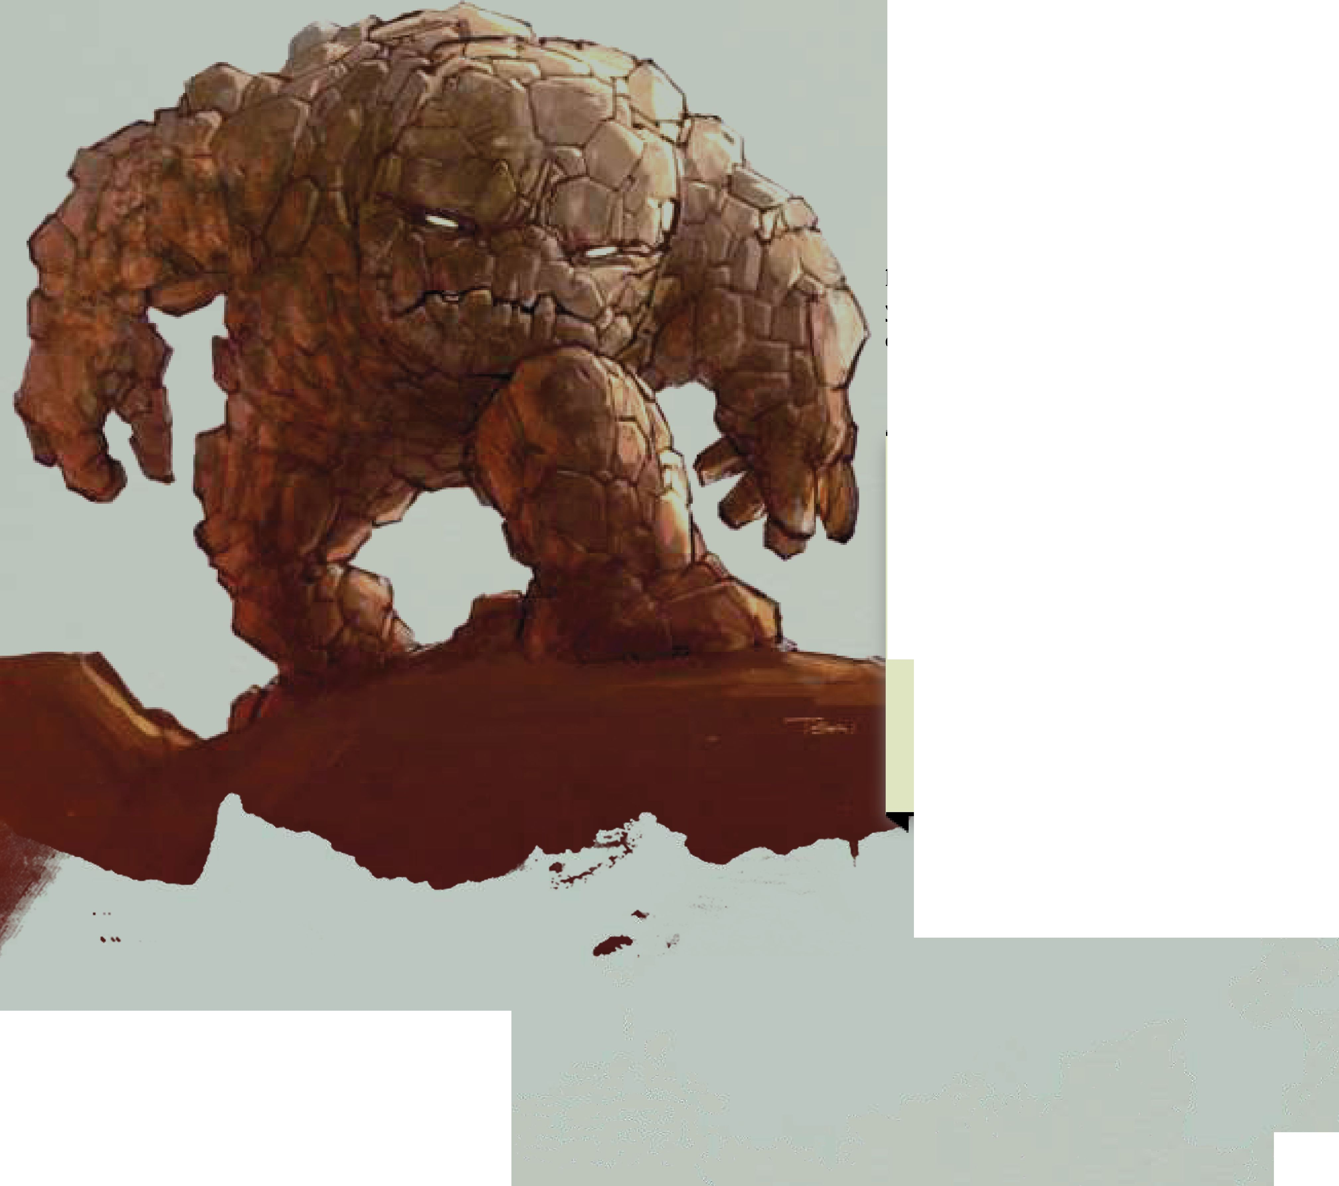

one creature. *Hit.* Id4 cold damage. The target must succeed on a constitution saving throw (DC 10) or have their speed halved until the end of their next turn.

**• Air.** Slam. *Melee Weapon Attack:* +4 to hit, reach 5 ft., one creature. *Hit.* Id4 thunder damage. The target must succeed on a constitution saving throw (DC 10) or be deafened until the end of their next turn.

The creature lasts for a number of minutes equal to your level They will perform whatever tasks they’re capable of that you assign them. Once you’ve used this ability, you must complete a long rest before you may use it again.

**Elemental Friend**

Your players will get a lot more out of Varn Magic if the creature they summon has a name, and personality.

Consider making this only a small portion of an elemental, more like a vessel that they are remotely controlling. That way, every time a particular elemental is summoned, it's an old friend.

Don't forget that this means that elemental exists somewhere, should the players want to visit their friend.

The lands of Damara have never been friendly. Dry, arid lands with frigid temperatures are no place for civilization but even those who eke out a life here are now under the tyrannical thumb of a malevolent dictator.

Shared Success

Regardless of where one finds work in Damara, it's never alone. Adventuring bands roam to slay monsters, soliders defend cities in formation, miners extract valuable minerals and metals without questioning one another. In the cold, savage north, you only survive together.

When you take the Help action to aid an ally with an ability check, they may add your proficiency bonus to the roll if you are also proficient with that same ability check.

If you take the Help action to distract a foe, the target has disadvantage to attack targets other than you until the end of its next turn. The next ally that successfully strikes the target before the end of your next turn deals extra damage equal to your charisma modifier.

The Great Dale

In the area known as The Great Dale, ancient kingdoms rose and fell, and all that's left is a ruin dotted forest land, seeded with a handful of farmsteads and villages.

The people of The Great Dale are vigilant against evil forces that threaten their homes, like trolls, orcs, or blighted undead

Vigilant Protector

Targeted by Impiltur's plans for expansion, the humble farmers and numerous druids are the last bastion of defense against such intruders.

You gain the following benefits:

* As part of any other action, you can draw or stow a shield
* If an ally within 5 feet of you is attacked you may use your reaction to grant them your proficiency bonus to AC. If you do, until the start of your next turn, the next attack that targets you has advantage.
* If an ally is brought to 0 hit points and the creature responsible is no further away than your base speed as a reaction you may move directly towards that foe and make a melee attack with advantage.

There is no one place in the realms like Waterdeep in terms of being a melting pot for culture. Impiltur, however, is more like a mosaic or tapestry where cultures don't bleed into each other but maintain a strong sense of self. Folks who live here learn from each other, but also fiercely protect their traditions.

Versatile

It's hard being surrounded by so many different cultures, not to be overwhealmed by the many viewpoints and opinions available to you at all times. Inevitably, you'll pick up some knowledge or skill that ends up being useful down the line.

Choose one ability score and increase it by 1, to a maximum of 20.

Additionally, whenever you make an attack roll, ability check, or saving throw, and you lack proficiency on that check, you may roll with advantage. If you use this ability, you must complete a short or long rest before you can use it again.

The Hordelands

Wide open steppes that stretch on for miles, the Hordelands are famous for being the first step towards the edge of the world They're known as by folks of Faerun and Kara-tur alike, for their lands being the point where the Tuigan hordes marched

It is said there are two sorts of folk who you'll find in the hordelands: the raiders who live there and the merchants who travel across it. While not entirely false the statement is quite disingenuous to the colorful tribes who remain scattered across the lands.

Steppe Walker

The natives of the hordelands stay aware of most threats, seemingly having developed a sixth sense for some of the more dangerous evils. You gain the following benefits:

* Proficiency in Nature and Survival If you already have proficiency with either of these checks, you may double it for that check unless you already have double proficiency for that check.
* You can cast *Detect Evil and Good* as an action. This lasts for 10 minutes without requiring concentration. If you use this ability, you must complete a short or long rest to use it again.
* You only need to eat and drink one quarter of what your race requires.

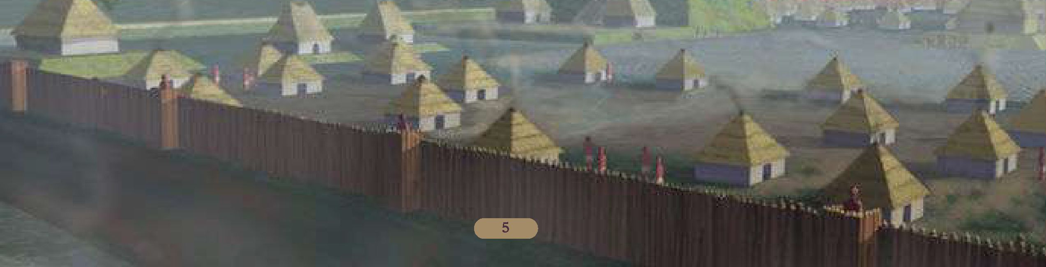

The tribes known as the Nar have a dark history that they are still try to escape. In years past, the Nar were famed for summoning demons to help them defend against their foes.

Now tribes ride across open plains hunting prey from horseback, their archers are famed for their incredible skill with the bow.

Horseback Archer

Turning away from their ancient practices, the Nar tribes have adopted the ways of the Tuigan hordes, becoming excellent hunters from horseback.

Increase your dexterity score by 1, to a maximum of 20.

While mounted, if you take the attack action with a ranged weapon, you may use a bonus action to make an additional ranged weapon attack.

Rashemen

The barbarians and witches of Rashemen are famed throughout Faerun for their staunch bravery, mystical magics, and strange ways. Their culture is unlike any other in all of the realms, and one they are reluctant to share with others.

Pair Bonded

The barbarian and witch pairs that adventure far from home are legendary stories to tell children across Faerun. But while it's a coming of age ritual for the Rashemi, in other places there are protectors who take similar vows.

When you take this feat, choose a single creature or character to become bonded with. You gain the following benefits, provided your bond is alive:

• You are always aware of the health of your bond If they're injured poisoned diseased or otherwise harmed you are aware of it as well as their emotional state.

* You're aware of the general direction and distance of your bond provided they're on the same plane of existence.
* If they're proficient with an ability, you are proficient with that ability as well

This does not grant additional proficiencies in skills.

Should your bond die you lose these benefits. You may choose a new bond after one year and one day, or if you get revenge on the creature that had killed your bond (if such a thing is possible) If your bond is resurrected before either of these things occur, your abilities return.

A surprisingly wide variety of cultures can be found in Thesk. Some attribute this to the large amount of trading that takes place here, thanks to being the first step of the Golden Way along the sea. This road connects Faerun to Kara-Tur.

Cosmopolitan Shadow

Living in a city where crime can be made legal with enough coin, you've learned about the darker side of mercantilism. You gain the following benefits:

* When you roll an ability check to search for mundane or magic items for sale within a city, you have advantage on that roll This applies to downtime activities as well
* You have advantage on any checks made to create new contacts through downtime.
* You have a sense that tells you if someone can be bribed, as long as you talk with them for at least 1 minute and their wisdom score is not greater than your charisma score.

Vaasa

The warlock knights of Vaasa are a terrifying force in a hostile nation. With the exception of a single city, most of the inhabitants of the swamplands are terrified by their presence.

Elusive Target

Needing to stay out of the way of the warlock knights, or any other Vaasan monster, you've learned to hide well

You gain the following benefits:

* You have advantage on any Dexterity (Stealth) check made to hide when you are in dim light or darkness.
* After you have taken the Hide action, you can move at your full speed without revealing your position immediately.
* Whenever you roll initiative in an environment of dim light or darkness, you can simultaneously take the Hide action if there is an appropriate place to hide within 5 feet of you. The wealthiest country on the Sword Coast, Amn is famed for Athkatla, the ’’City of Coin”. Filled to the brim with nobles, heroes, villains, and intrigue, if one seeks excitement they find their way to Amn.

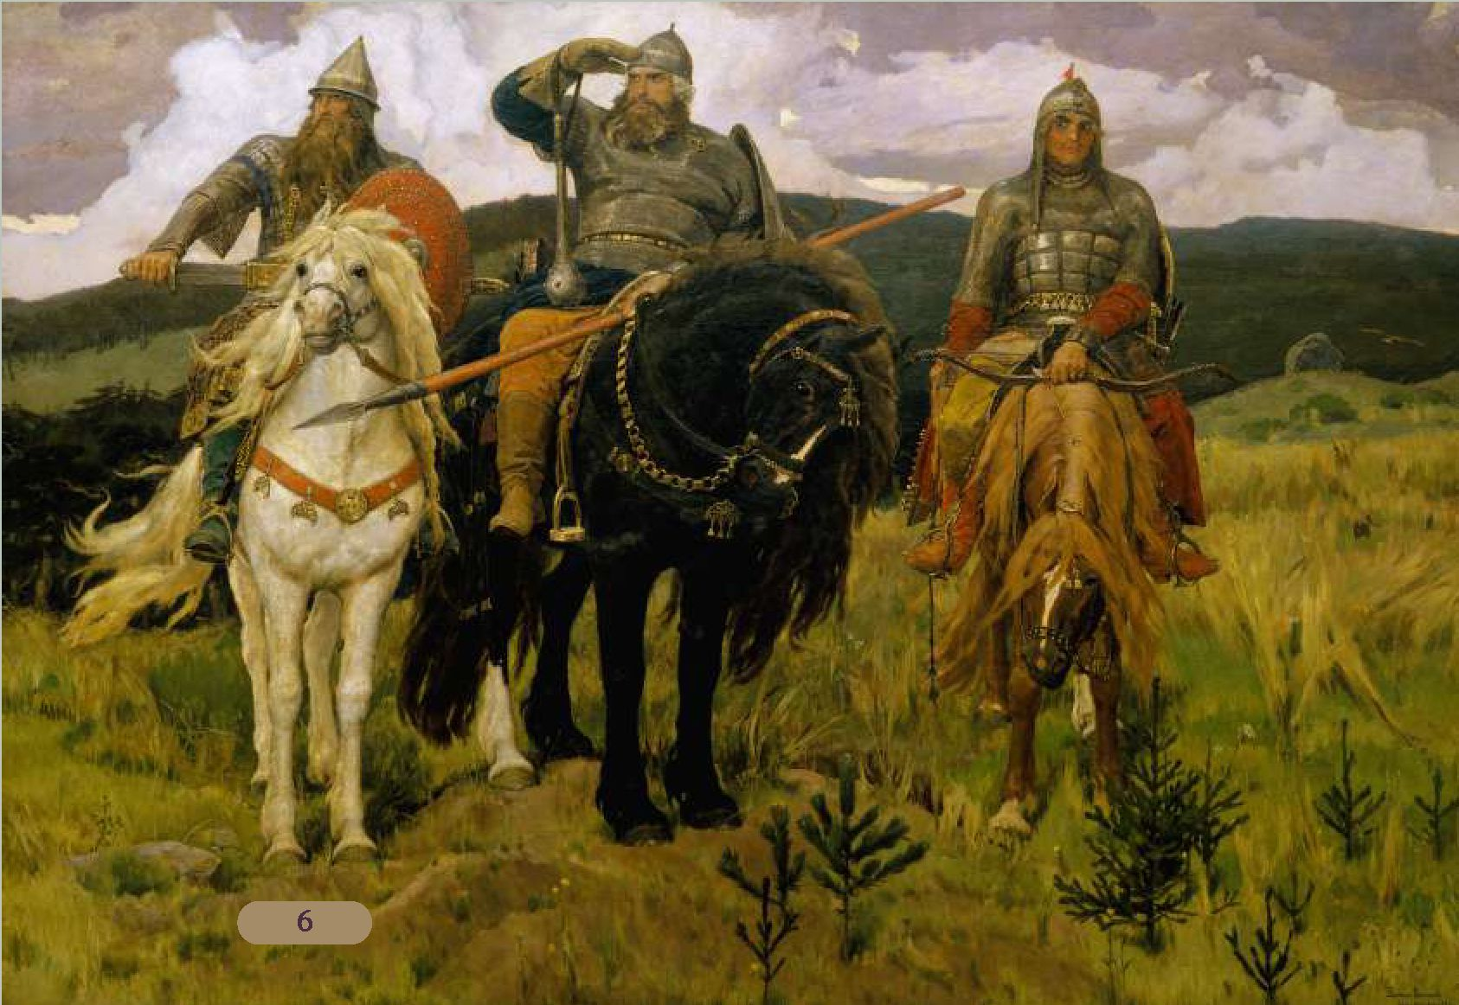

Banner Bearer

The proud mercenary companies that come out of Amn are famous for carrying banners into battle, their standard bearers being greatly respected.

Provided you are carrying a banner in at least one hand, you gain the following benefits:

* Allies have advantage on saving throws against fear or being charmed, as long as they are within 10 feet.
* Allies who regain hit points may add your charisma bonus, provided they are within 10 feet.
* As a reaction to an ally gaining a condition, they may immediately make a saving throw to end that condition as long as they are within 10 feet.

If the banner is magical each of these benefits can be used if the ally is within 20 feet instead of 10 feet. You can use your action to hold your banner aloft, doubling the range that allies can benefit from the effect.

A creature can only gain the benefits of this feat from a single source.



**What Is A Banner?**

A banner is an object that needs to be held high and visible. Typically it has a standard or icon upon it that creatures can see.

While this is traditionally a tall pole, with your DMs permission you can attach your banner to an appropriate two handed weapon or versatile weapon such as a halberd or pike.

K



The Gate is known for being a metropolis separating the south and northern sections of the Sword Coast.

The crowded, claustrophobic streets, aren’t as inviting as those of Waterdeep, and coin doesn’t flow nearly as freely as in Athkatla, but the citizens who live here find Baldur’s Gate to be the best of all cities.

Gather Your Party

Before venturing forth, it’s always good to have someone watching your back. This is the basis for adventuring parties, and a praised idiom around Baldur’s Gate

Whenever you finish a long rest you and up to five nearby allies gain the following benefits that last until your next short or long rest:

Temporary hit points equal to your level

Each character has advantage on their next saving throw they are forced to make.

Each character has advantage on the next group check they need to make.

**Rules Reminder**

If more than one character in the party possesses this feat, it does not stack. Temporary hit points never stack and the wording of "on their next" indicates that once that occurs, the benefit is lost even if more than one party member has the feat. Calimshan known for many things: a harsh climate, powerfully rich leaders, and strange elemental magics. But more than anything, Calimshan is known for the webwork of schemes that occur behind the scenes.



Schemer

The shady sands of Calimshan are hot with the intrigue of poisoned tongues. The most formidable and influential powers of the country are those with the sense to have a thousand plots ready at any moment.

During a short or long rest, you may create a plan with one of your allies.

This functions as a readied action, but lasts until the next time you take a short or long rest. Even with a scheme prepared, you can still use readied actions.

Determine a triggering condition that will cause your scheme to activate, and you each choose an action to occur when it does. That action cannot be cast a spell unless the spell can be cast as a reaction or as a bonus action.

When the condition triggers, you may each use your reaction, causing your prepared actions to activate. You must be within 30 feet of each other, be able to see and hear each other, and you must each have your reaction available, or you cannot activate your scheme at that time.

Once used a scheme cannot be used again until you take a short or long rest, or until you replace it with a different scheme.

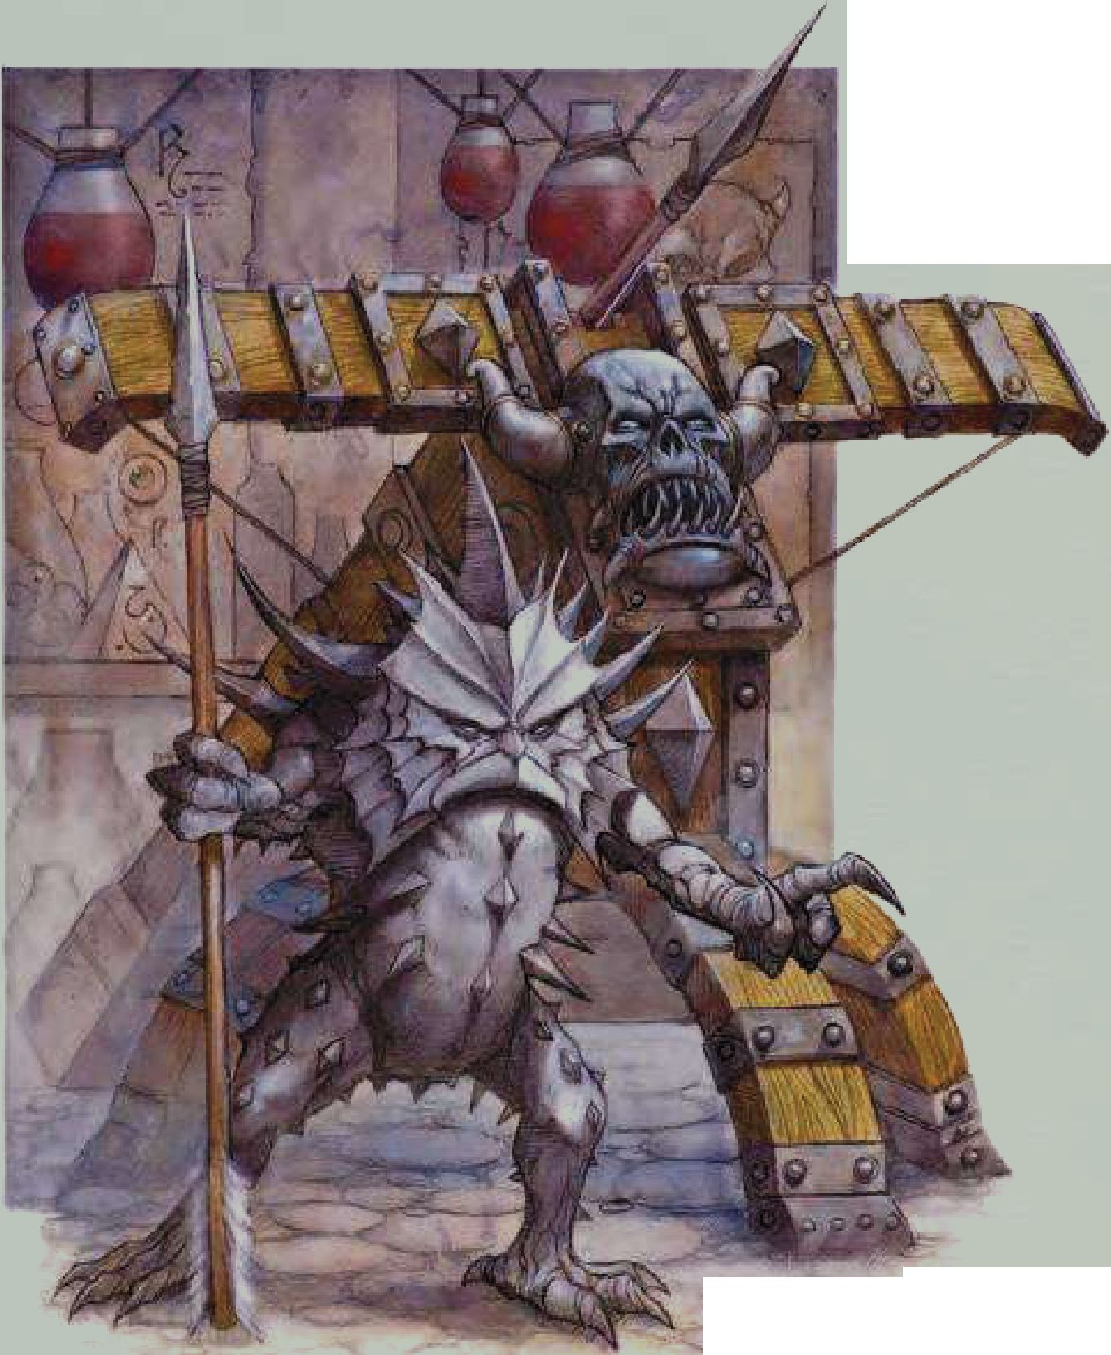

Lantan - once thought lost was rediscovered after the second Sundering. Now it largely features as the center of inspiration for inventors and artificers.

Arcane Assistance

Those folks who delve into the arcane often spend years even attaining the basic levels of mastery. That's why most of those scholars first learn how to summon assistance to keep their living areas in order.

As an action, you can cast the *Unseen Servant* spell with the following modifications:

The spell must be cast upon a medium or smaller object. This causes the object to animate and perform the given tasks. Instead of the traits of an Unseen Servant, it has an AC of 8 + your proficiency modifier, and a Strength equal to your proficiency modifier. Unlike the unseen servant, your servant can move more than 60 feet from you but not more than 60 feet from where it was animated

Additionally, your servant can cast *Mending* and *Prestidigitation* each as an action but can only use them as directed

You may use this ability a number of times equal to your intelligence modifier (minimum 1). You regain all uses of this ability after completing a long rest.

Lantanese Effort

Building golems and clockwork creatures is hard work but is a field that fascinates most. Of course the gnomes of Lantan are second-to-none when it comes to crafting anything magical Increase your Intelligence score by 1 and gain proficiency with one tool of your choice.

Additionally, you gain the following benefits:

* Whenever you spend downtime to craft, if you are proficient with the tools used with that craft, you double any progress made.
* If you spend your downtime crafting or selling items you crafted your lifestyle expenses are treated as one higher than you paid for this week.
* You are able to procure materials more effectively. If you spend at least a week in a city, any materials you buy for your craft cost 10% less.

The Moonshae Isles

The many islands that make up The Moonshae are ruled by the human and fey courts. While sometimes there is friction between these two factions, they are currently enjoying a period of stability.

Myths and Legends

The heroes of The Moonshae Isles often undertake grand quests. When on such quests, it can be difficult, even via magic, to turn them from their goals.

Increase your Wisdom score by 1, to a maximum of 20.

Additionally you gain the following benefits:

* You can read, write, and speak Sylvan.
* If you're under the effect of a spell from the school of enchantment or illusion that forces you to make saving throws at the end of your turn, you may instead make those saving throws at the start of your turn.

Romantic Duelist

Ardent love, bitter rivalry, and fiery passions flow through the human and elven courts of the Moonshae Isles.

You gain the following benefits:

* If you're wearing no armor and using no shield, your AC is 10 + your dexterity and charisma modifiers against any attack you are aware of provided you are not incapacitated
* You gain proficiency with Performance. If you are already proficient, double your proficiency bonus instead
* You have advantage on any ability check rolled for the purposes of love, wooing, or otherwise engaging other characters romantically.

Nimbral

A hidden island nation of pegasus riders and arcanists, Nimbral is one of the most mysterious of human settlements. Using their magics, as well as ancient elven spells woven into the region surrounding the islands, the Nimbrali have successfully turned away any would-be intruders for centuries.

Nimbrali Magic

One manages to pick up a spell or two when living on a magic island for centuries. Most folks from Nimbral possess some small amount of illusion magic. This allows them to confuse would-be visitors and convince them to leave without revealing themselves.

You can cast the *Minor Illusion* cantrip. You also learn the *Silent Image* and *In visibility* spells which can each be cast once without expending a spell slot or material components. You regain the ability to cast these spells when you complete a long rest. Intelligence is your spellcasting ability for all three spells.

Aerial Pilot

Nimbral was a wealthy island nation and, therefore, the target of slavers and pirates. Powerful pegasi-mounted warriors protected the islands and were mythical flying protectors on Abeir-Toril

You gain the following benefits while mounted on a flying creature or piloting a flying vehicle:

* If your mount or vehicle is rendered unconscious, dead, or otherwise incapable of flying and it has a fly speed, it benefits from the effects of *feather fall* as it glides to safety.
* While flying high above the ground, you can utilize clouds and line of sight to make Stealth checks even without reliable cover or concealment.
* You can use your bonus action to double the fly speed of your mount or vehicle until the end of it's next turn. Once you use this ability, you must complete a short or long rest before you may use this ability again.

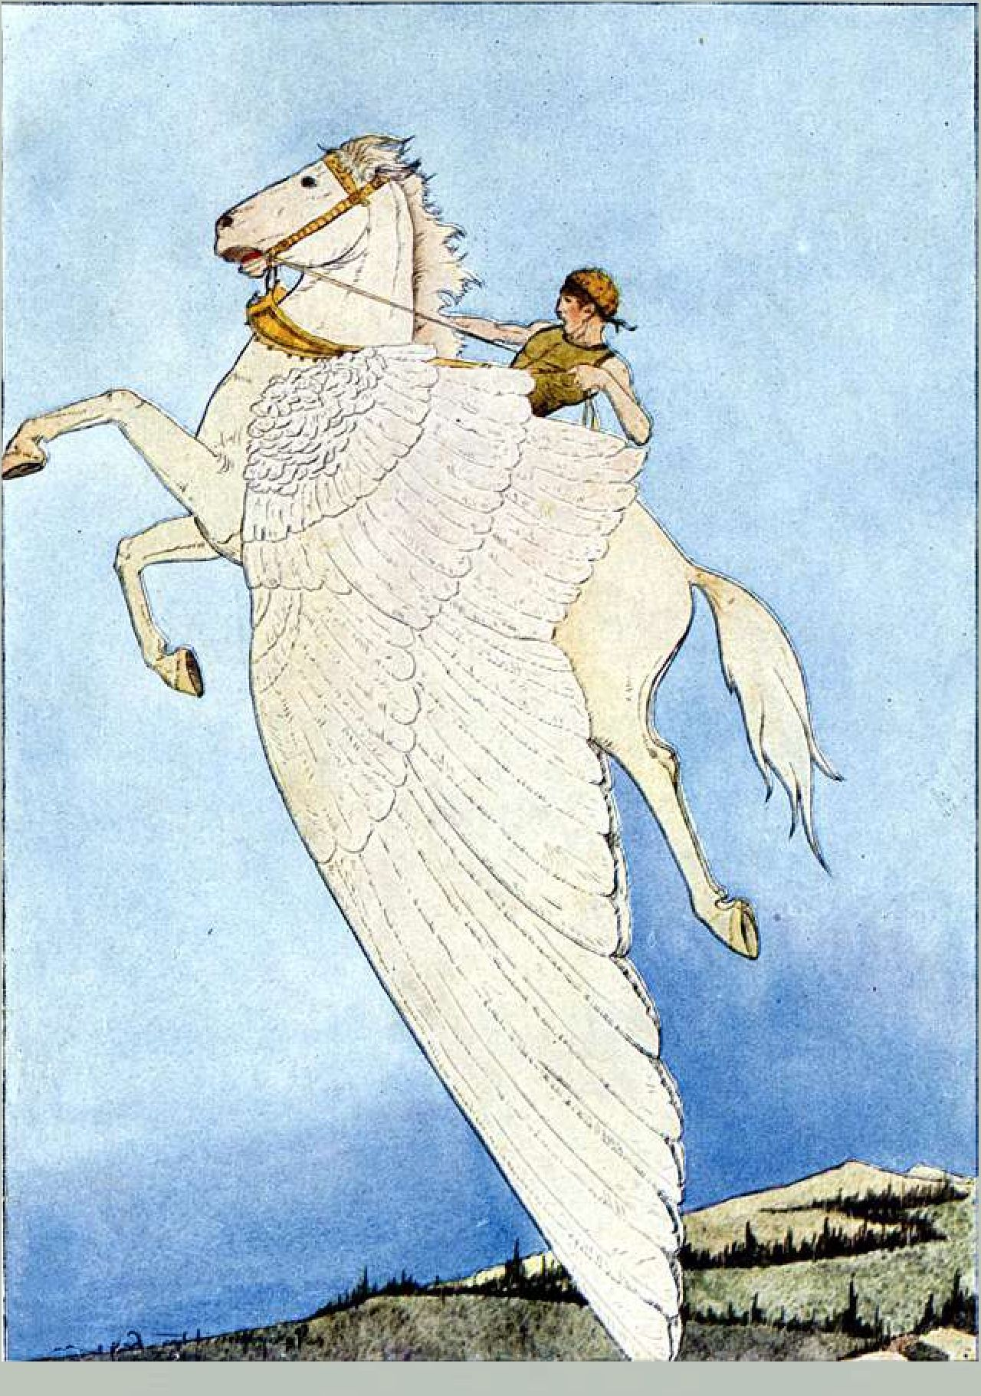

a*

The Nelanther Isles

Commanded by the pirates who ravage and harass ships up and down the Sword Coast, the Nelanther Isles are a wretched hive of scum and villany.

Loyal Band

Your legend has grown, attracting those who want to join you in glory. These followers will follow around with you and obey your orders, should you continue to lead them towards that glory.

|  |  |  |
| --- | --- | --- |
| **Your Level** | **Maximum Number of Normal Followers** | **Additional Number of Special Followers** |
| 1-4 | 1 | 0 |
| 5-9 | 1 + your charisma modifier | 1 |
| 10-15 | 1 + your charisma score | 2 |
| 16+ | 1 + double your charisma score | 3 |

If any of your followers die, you must spend downtime in a populated locale where you restore ld6 followers per workweek.

If you mistreat any followers you lose ld6 of them per week, at their earliest opportunity to leave.

Special followers will be of a higher quality than your usual followers and your DM will likely want to incorporate them into the story. Regular followers will be either **Bandits, Cultists,** or **Guards** (CR 0-1/8) while special followers are determined by the chart below.

|  |  |
| --- | --- |
| **Your Level** | **Special Followers** |
| 1-4 | -- |
| 5-9 | Acolyte, Scout, Thug (CR 1/4-1/2) |
| 10-15 | Bandit Captain, Cult Fanatic, Spy (CR 1 -2) |
| 16+ | Priest, Veteran (CR 3) |

**Friends And Followers**

Originally, the *Loyal Band* feat was just going to apply to pirate crews. As we developed it, we realized that the same could apply to cults, or adventuring bands, or even traveling troupes of bards!

Work with your DM if you want special followers that aren't listed here.

F

Tethyr

After long standing civil war, the dust has finally settled and structure restored to tethyr. That’s not to say things are stable, with nobles now vying for the attention of the crown, trying to curry favor without resembling boot-lickers.

Poison Tongue

The courtly intrigues of Tethyr run deep, with tangled threads of deception and honor confusing and confounding those not quick enough to follow those machinations.

Increase your Dexterity or Charisma score by 1, to a maxmimum of 20.

You also gain the following benefits:

* You have advantage on ability checks to discover or identify poison.
* You have advantage on sleight of hand checks to use poison discretely.
* If you suffer disadvantage on charisma ability checks due to social standings (for example, if you’ve been discovered to be part of an assassination plot, or undermining local merchant guilds), you do not suffer disadvantage on these checks.

The Western Heartlands

A handful of towns dotting a landscape rich in cultural and biological texture, the Western Heartlands were united under the four gods of the Order of the Gauntlet. Now their riches flow as far as Baldur’s Gate and out into the Sea of Fallen Stars.

Merchant

With the region united by the Order of the Gauntlet, most of the merchants of the region are regarded as fair and even­handed. Their drive to compromise is often compared to that of court diplomats.

Increase your Charisma score by 1, to a maximum of 20.

Additionally you gain the following benefits:

* Whenever you sell arms, armor or other equipment, you sell it for 75% of the value instead of 50%.
* Whenever you sell trade goods or art objects (but not gems or jewelery), provided you did not purchase those goods where you are selling them, you can increase their value by %10 x your Charisma modifier.
* If an item has a listed GP value, you know what that value is. You do not know the exact gold value of items listed by rarity, such as magic items.

The modem country of Chondath is a pale echo of the once- proud nation ruled by psionists. These days, the magic-fearing dwellers tend to live simple, pious lives.

Latent Psionics

The empire of Jhaamdath was ancient when it fell, and that was already long ago. Today, it's rare for people to exhibit the talent within their blood, however you have tapped into an inner well of power.

You can cast the *Message* cantrip without pointing a finger or requiring components.

You can also cast *Command* and *Detect Thoughts* once each without using any material, verbal, or somatic components. You must complete a long rest before you can cast these spells again. Intelligence is your spellcasting ability for all three spells.

Cormyr

The kingdom of Cormyr, land of noble knights and a long history steeped in war. The kindgom is known for being orderly, almost restrictively so depending on whom you ask.

Law and Order

Knowing the laws and restrictions of the cities you visit has made the difference between heroes and renegades. As wizards say: knowledge is power.

You gain proficiency with History and Investigation.

Additionally, if you take a short or long rest in a city, you gain the following benefits in that city:

* You know the local laws and regulations. When you observe an action taken by you or your allies that would transgress upon these rules, you're aware of it before hand
* You have advantage on charisma ability checks made to defend yourself or your allies in a court of law, against rule enforcers (such as guards) or similar situations in that city.
* You know the appropriate punishment for any given crime in that city.
* If you spend your downtime working for the administration of the city, your lifestyle expenses are treated as one higher than you paid for this week.

Your DM may rule that a city has changed so much since your last visit, that you must complete another short or long rest to regain these benefits. Otherwise, these benefits are permanent for you for that location.

The serpent kingdoms are spoken of in whispers in other realms, but their society is a strong and proud one with a long heritage.

Malison

Undergoing a transformative process, you've emerged one of the yuan-ti experiments.

You gain the following benefits:

* You can cast *Animal Friendship* at will without requiring any components, but you can only cast it on serpents.
* As an action, you can shapeshift into the form of a medium snake for 1 hour. While shapeshifted this way, you can revert back to your original form as an action. This functions like the *Wild Shape* ability of the druid Once you use this ability, you must complete a long rest to use it again.

Additionally, your form becomes one of the following (roll randomly or choose):

1. Your head is replaced with a serpent head
2. Your arms are replaced with snakes.
3. Your lower body is replaced with a serpentine one.

When you successfully strike an opponent with your unarmed attack, as a bonus action you may apply the following benefit based on your form:

1. The damage dealt is piercing damage and the target takes ld4 poison damage.
2. The damage dealt is piercing damage and you may attempt to grapple the target.
3. You attempt to shove the target.

The Pirate Isles

The Pirate Isles are home to many brigands and thieves, all serving across various pirate crews. At one time, there was even rumor of a pirate king, although most folk say that's simple rumor.

Fight Dirty

Sembia and Waterdeep might be known for their flashy fencers, but the true spectacle of combat is unleashed when you get a room full of drunken pirates fighting over cheating at cards, divvying up treasure, or just realizing that it's Thursday.

You gain the following benefits:

* If you use your environment to aid in your movement (such as swinging from a rope or leaping from a mount) at least 10 feet towards a foe, you may use your bonus action to make a melee weapon attack against that target with advantage.
* After making a successful melee attack, you can use your bonus action to attempt to shove or grapple.
* Using your bonus action, if you're holding a weapon you can fling small objects nearby at a target within 5 feet of you. The target must succeed on a dexterity saving throw with a DC of 10 + your proficiency modifier, or the next attack against them has advantage.

The nobles of sembia are always looking to outdo each other, in whatever forms they can find. Sometimes it's all about owning more than another family, while other times it could be taking pride in having a scion become the most successful tailor in Waterdeep. For sembians, there is no pride before the fall

Sembian Fencing

Combat is seen as equal parts sport, defense, and fashion. It seems there isn't a house in Sembia that doesn't possess some secret, personal technique with a blade.

You gain proficiency with Knowledge (History} If you already possess it, you double your proficiency bonus.

When you are attacked and the attacker misses you and is within melee reach, if your weapon has the light or versatile properties, you may use your reaction to make a melee weapon attack against that target.

Shadovar Vassal

Netheril's return was one of the darkest times in Sembian Turmish is famed for their horses and their expansive republic. The people of the realm are asked to serve time on the council, a great honor to most.

Skilled Negotiator

Your time spent on the assembly or around the center of Turmish government has given you a decided appreciation for the art of compromise.

You gain the following benefits:

* Increase your Charisma score by 1, to a maximum of 20.
* You gain proficiency in the Persuasion skill If you are already proficient in this skill you add double your proficiency bonus to checks you make with it.
* If you spend 1 minute talking to someone who can understand what you say, you can make a Charisma (Persuasion) check contested by the creature’s Wisdom (Insight) check. If you or your companions are fighting the creature, your check automatically fails. If your check succeeds, the target is charmed by you as long as it remains within 60 feet of you and for 1 minute thereafter.

history. Little better than slaves, the nation rolled over for their masters. However, the Shadowvar were not emotionless, and inevitably there were those bom of their blood

Increase your Constitution score by 1, to a maximum of 20.

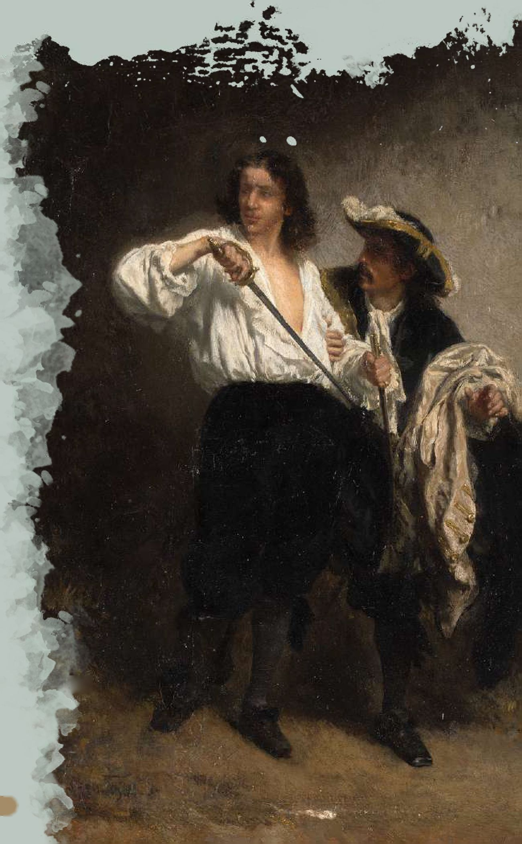

You have resistance to necrotic damage and poison damage. You have advantage on saving throws against poison. If you do not already possess it, you gain darkvision out to 60 feet.

Aglarond

The isolated lands of aglarond have never been historically stable. While the common citizens are able to go about their lives, the entire structure of leadership is built to defend them from outside threats. From inhospitable fey to the red wizards of thay, aglarond is never long without excitement.

Peltast

Chessentan armies are feared for their long distance engagements. Using thrown weapons to weaken their foes, staying out of range until the time is right before finally moving in for the kill

Increase your strength score by 1, to a maximum of 20.

You gain the following benefits:

Fey Friend

While not always on peaceful terms with the nearby fey, the folk of aglarond have a greater understanding of their ways.

Increase your Charisma ability score by 1, to a maximum of 20.

In addition, you gain the following benefits:

* You learn Sylvan, if you do not already know it.
* When making charisma based ability checks against

creatures of the fey type, you can double your proficiency bonus.

* If a creature of the fey type casts an enchantment or illusion spell another creature, you can make an insight check against the caster's spell save DC to become aware of the result of their saving throw.

Chessenta

One of the few ancient empires that still exists to the modem year, although quite changed from when it was first established Modem Chessenta has been riveted with drama, from bone dragons to a giant sphere of annihilation floating above the land

Educated

The common folk of Chessenta tend to fall into one of three categories: those who work magic, those who develop philosophy, and those who create art. Knowledge is seen as something all should have access towards, and so even the common folk are quite educated

Increase your Intelligence score by 1, to a maximum of 20. Additionally, you gain the following benefits:

* You gain proficiency with one tool that you are not already proficient with, and you double your proficiency bonus for checks made with that tool
* You gain proficiency with Perform, and one intelligence skill of your choice.
* You learn one wizard cantrip. Intelligence is your spellcasting ability for this cantrip.
* Treat melee weapons with the thrown property as though their range is double.
* After attacking using a melee weapon with the thrown property, you may immediately draw a melee weapon using no action provided it is not stored in an inaccessible way.
* After attacking using a melee weapon with the thrown property, you may use your bonus action to move up to half your speed

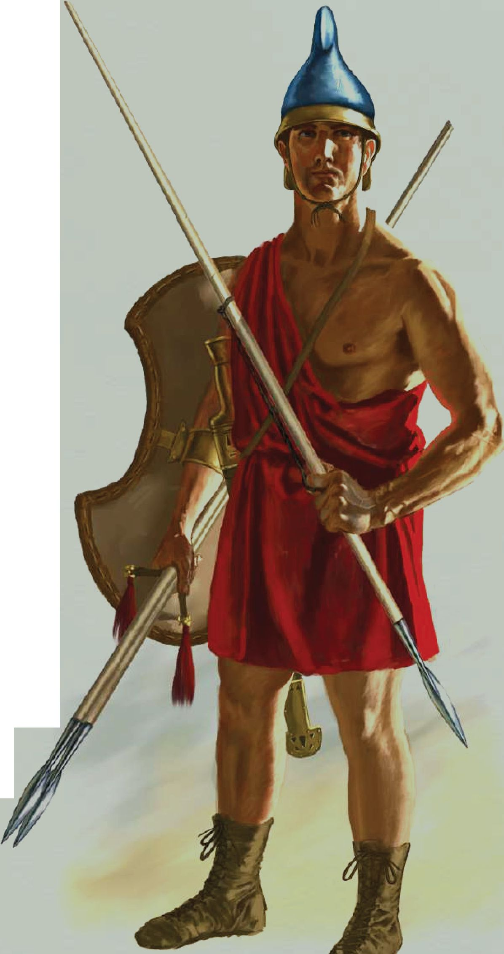

**•13 B**

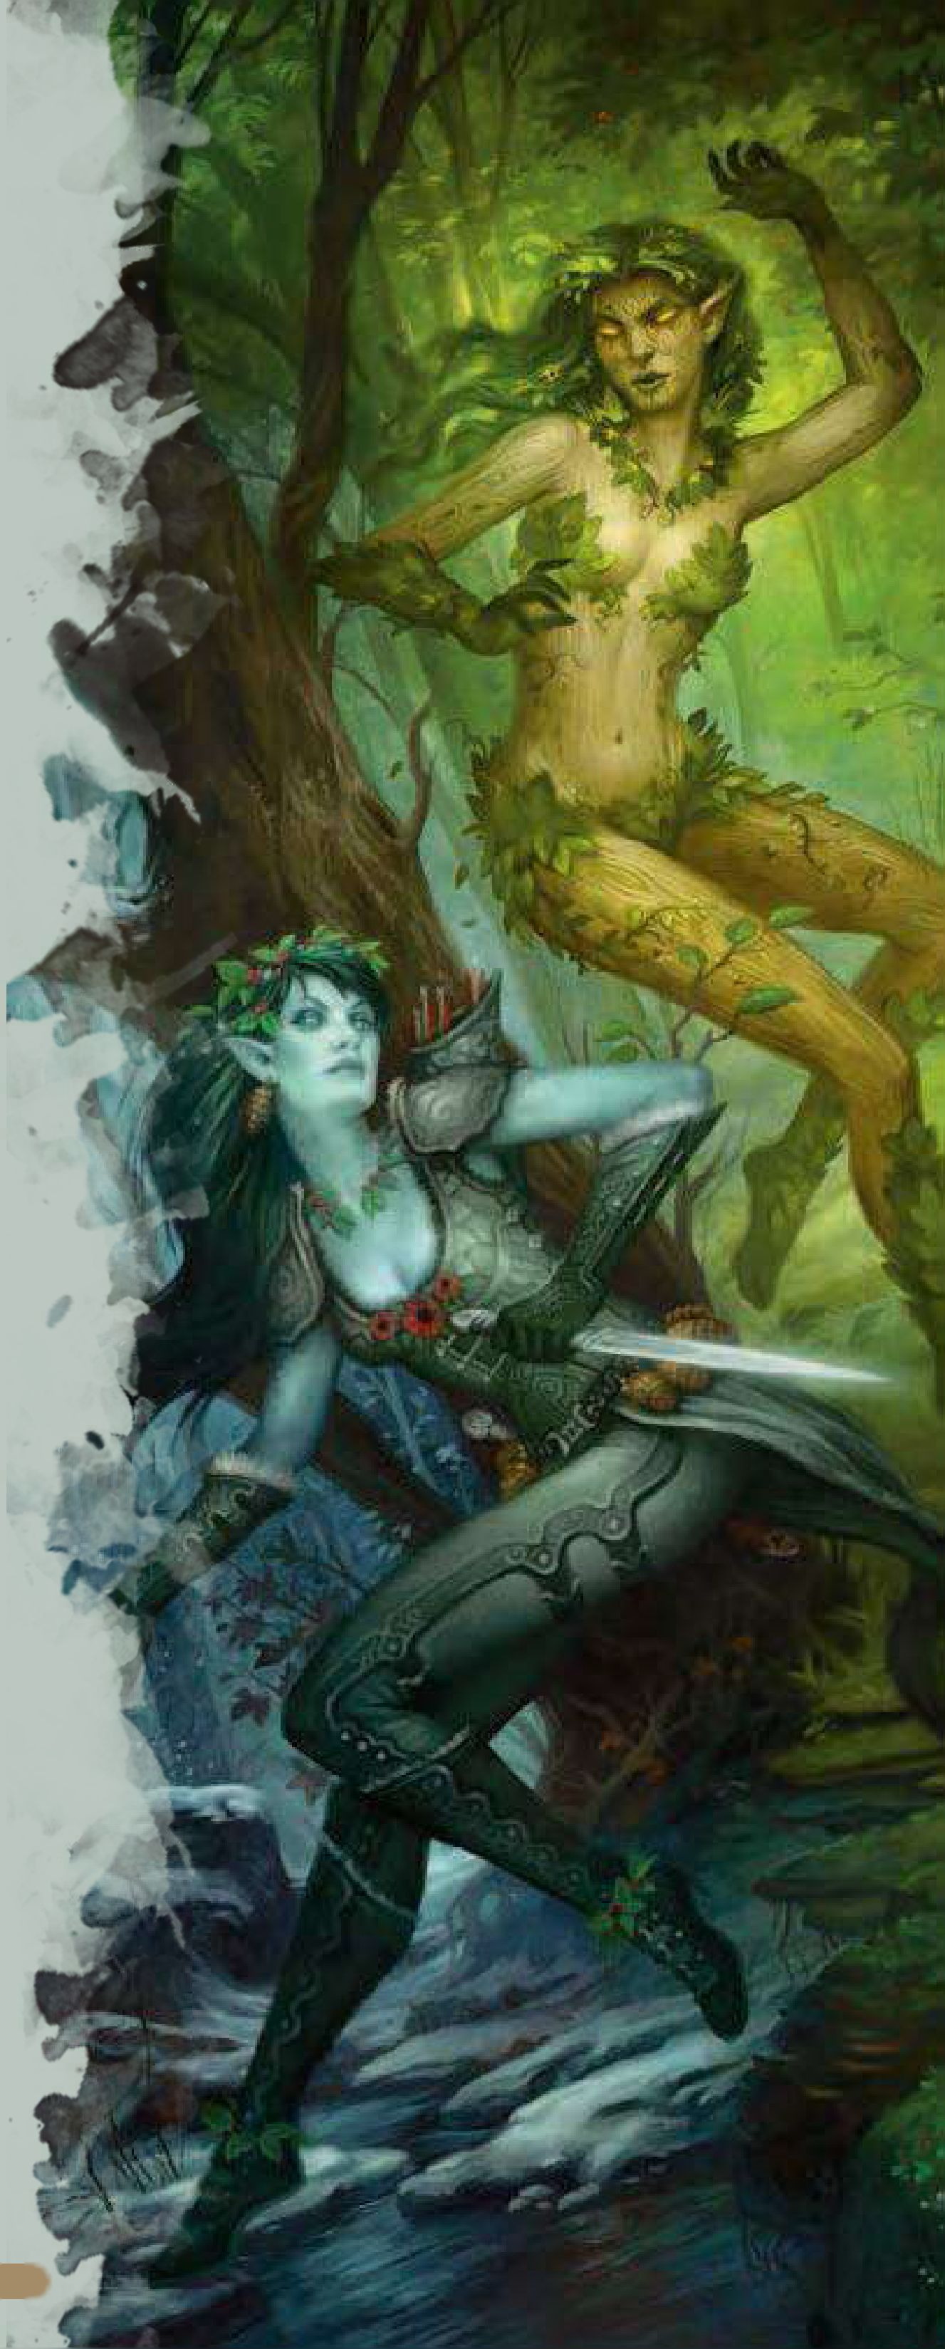

Chondalwood

An ancient forest inhabited by elves, fey, and ghostwise halflings. Any cities bordering the woods cany warnings about venturing into (or even worse, foresting) the woods, for fear of people going lost or being transformed into twisted creatures.

Fey Shadows

Learning how to hide and listen to nature from the fey who stalk the chondalwood, you've learned how to hide yourself exceptionally well

You gain the following benefits:

If a creature would gain advantage on checks to track you by sight, sound, or scent, they do not gain those benefits. During a short or long rest you can gather materials from the terrain around you and integrate it into your clothing. This allows you to use the hide action in plain sight. However, if you are attacked, this benefit is lost until you complete another short or long rest.

During a short rest, you may make an insight check to determine if you are being tracked magically or mundanely. The DC for this check is 15.

During a short or long rest, if you have magic actively tracking you, you may expend a hit die to create an effect that functions like *Dispel Magic* or *Cotinterspell,* ending the magic that's tracking you. If the magic that tracks you is 4th level or higher, the caster must succeed on a saving throw using their spell casting ability or the spell ends. The DC for this saving throw is 8 + your wisdom modifier + your proficiency bonus. Once you use this ability, you must complete a short or long rest to use it again.

S'

Mulhorand

Wresting control from High Imaskar, the lands of Mulhorand are ancient and threatening. With Unther and Tymanther warring at their gates, they need to be always alert.

Theocratic Nature

The people of Mulhorand have tightly integrated their spiritual life with their daily ones. Having seen their gods walk their lands, every aspect of their lives is somehow tied to those deities.

You have a pool of piety points equal to your Wisdom modifier plus your proficiency bonus.

As part of a long rest, you can perform prayer services.

Doing so takes at least one hour of religious activity, at the end of which you regain all your piety points, which can be used for the following:

* Use a piety point to gain temporary hit points equal to your level plus your wisdom modifier.
* When you are required to make a saving throw, you may use a piety point to use your wisdom instead of the required ability.
* As a reaction to being attacked, you may use a piety point to add your wisdom modifier to your AC against that attack.

The dragon princes rule over this nation on the border of Thay. While some of these princes rule with a just claw, others are far less benign. And it seems everyone, from the humans who serve to those who rebel, has a unique perspective on the situation.

Draconic Infusion

Your body has been laced with draconic arcane arts. You gain the following benefits:

* Increase your Constitution score by 1, to a maximum of 20.
* Choose a draconic heritage line from the Dragon Bloodline sorcerer and gain resistance to the energy type associated with that bloodline.
* If you cast a spell of the first level or higher that requires an attack roll and deals damage, you may deal damage equal to your charisma modifier to one of the affected targets. This damage is of the same type done by your selected heritage.

Thay

Famed for their much maligned Red Wizards, Thay is undoubtedly famous for the pure power that they've invested into magics. The zulkir rulers are some of the most feared beings in all of Faerun, and there are few foes as deadly as Szass Tam.

Magic Tattoo

In Thay, it's common for mages to get tattoos with which to focus power and defend themselves. Of course, they're hardly the progenitors of this magic, making it rare (but not unheard of) elsewhere.

Your body is covered with arcane tattoos. Choose one school of magic. You gain the following benefits:

* Whenever you make saving throws against spells from your chosen school, if you are not proficient with that saving throw, you may add your proficiency bonus to the roll
* Whenever you make checks to maintain concentration with spells from your chosen school your checks are made with advantage.
* Checks made from the *Dispel Magic* and *Cotin terspell* spells have disadvantage against your spells from the chosen school

Locked in war against the forces of Gilgeam and Unther, the dragonbom of Tymanther are adamant in holding their lands in Toril They may not be from here, but it's clear that they've made a new home for themselves and they're not going to simply hand that over to anyone with a sword

Tenacity

If there's one unified trait across the folk who call Tymanther home, it's their inability to stay down or give up. You gain the following benefits:

* Whenever you fail a saving throw, you gain temporary hit points equal to your level
* If you fail a saving throw, you may use your reaction to make another attempt.
* You have proficiency on death saving throws. This doesn't change the effect of rolling a 1 or 20 on a death saving throw.

Unther

The people of Unther have lived through the worst tragedies in history. Having their homelands sent to Abeir during the spellplague, and then returned only to have their lands occupied by a nation of dragonbom, their ambitions are fueled by righteous rage.

Leadership

Unther has many heroes, with epic poems or songs written every year for each one. With a long tradition like this, many folk find themselves inspired by their acts enough to try to forge their own historical moments.

Increase your Charisma score by 1, to a maximum of 2Q

Additionally, when you strike a foe with a melee or ranged weapon attack, you may choose to deal only your ability modifier for damage. If you do, choose one of the following:

* One ally who can see and hear you gains temporary hit points equal to your Charisma modifier plus your proficiency bonus.
* One ally who can see and hear you may use their reaction to move up to their speed towards you. Any attacks of opportunity they suffer have disadvantage during this movement.
* One ally who can see and hear you may use their reaction to gain advantage on their next attack. If they do not attack before the end of their next turn, this bonus is lost.

**Reminder:** This ability says you may choose to deal only your ability modifier for damage. This means you do not get sneak attack, or any additional damage from spells like *hex* or *hunter's mark.*

The jungles of chult are not for the faint of heart. Merchant princes control the ports, while dinosaurs and undead roam the wilds. Only the most stout and sturdy survive.

Jungle Survivor

From guides to natives, everyone has tips and tricks for surviving the harsher places of the jungle. You gain the following benefits:

Increase your Constitution score by 1, to a maximum of 20.

* When you make constitution saving throws due to environmental effects such as humidty or heat, you have advantage on the saving throw.
* As part of a short rest, if you have the appropriate tools (generally, a set of Brewer's Tools or similar improvised set) you can purify water. This allows you to purify enough water for one creature for one day. If you can store the water, as part of a long rest, you purify enough water for four creatures for the day.
* If you setup camp, you can take 1 hour to ensure the camp will be hard to find. Creatures have disadvantage on perception rolls to discover your camp.

Elf Harrow

Once the shining country of Lapaliiya, these lands are now a barren desert. Currently, there are tribes of wild elves who live here, refusing to let any outsiders pass through the country. Of course, that doesn't stop those looking to loot the ruins that dot the wasteland

Tomb Raider

Aside from the wild elf tribes, the only other people you'll find in Elfharrow are dungeon delvers seeking the lost treasures of Lapaliiya. Their skills are quite useful to any who would reclaim the treasures of the dead

Increase your Dexterity score by 1, to a maximum of 20.

Additionally, you gain the following benefits:

* You gain proficiency with Dexterity saving throws and double your proficiency bonus when making saving throws caused by traps.
* You +2 to your AC against traps if you are not using a shield and are not incapacitated
* You're always aware of how much time has passed even if you cannot see the sky. You're always aware of how deep underground you are.

Vassal of Nimbral, the mythical nation of Samarach is known for cloaking their mountain passes with illusion magics. To even begin to understand their paranoid nation would take most scholars an entire lifetime.

Paranoia Agent

Thanks to nations of Farunians who do not understand them and invading yuan-ti, the people of Samarach have actually incorporated lying into their social norms. This level of fear is unseen anywhere else in the realms.

You gain the following benefits:

* You have save against ongoing enchantment spells at the start of your turn, instead of the end of your turn.
* You have proficiency with Insight and Investigation. If you already have proficiency with either of these, your proficiency bonus is doubled
* You have advantage on saving throws against spells from the illusion school

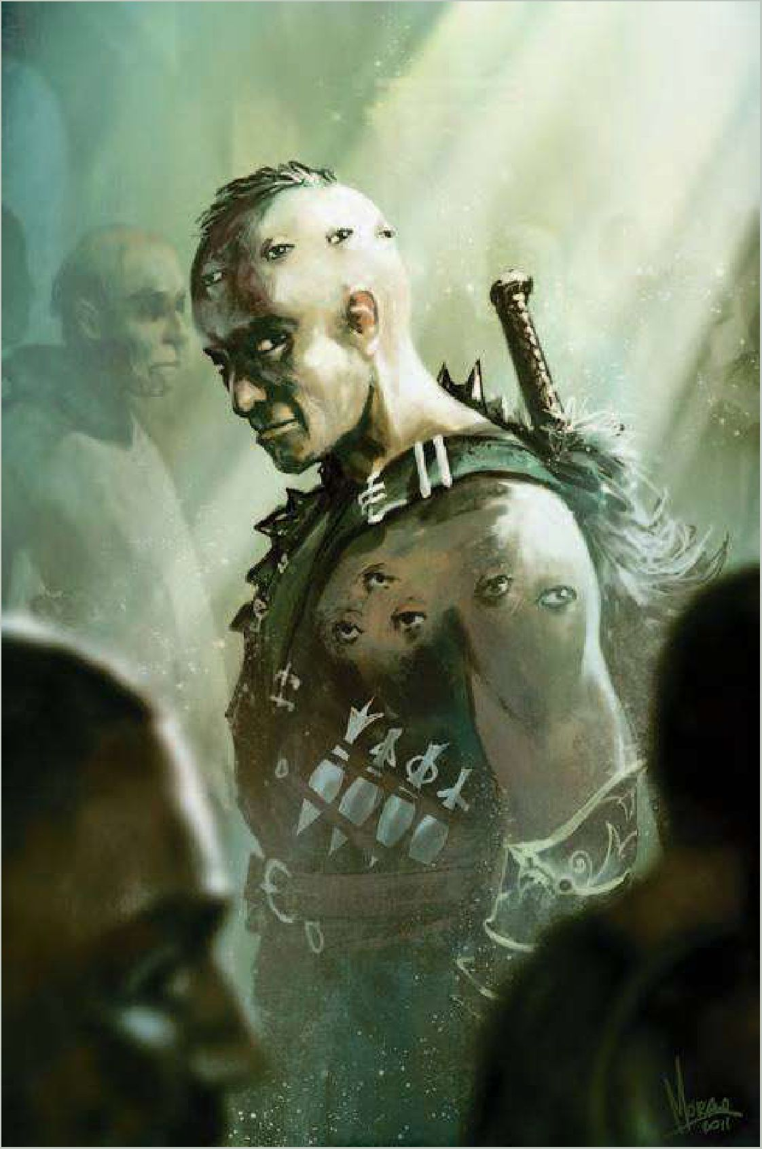

The Border Kingdoms

The ever present rise and fall of the many border kingdoms is as a heart beat in this region. It's not uncommon for a kingdom to rise and fall all within the span of a decade, a surprising norm for those who live here.

Pathfinder

With so many kingdoms changing hands, one is never sure if they'll be welcome beyond the gates. That's why it's always good to excel at making an exit.

Increase your Intelligence score by 1, to a maximum of 20. Additionally, you gain the following benefits:

* Once you've viewed a map of where you're going, you cannot become lost in the surrounding regions. You lose this benefit if you take a long rest.
* When traveling alone, you travel twice as far as others of your race. Your DM may allow you to use this feat while mounted and to travel with others and take advantage of this, provided all travelers possess this feat.
* When you complete a long rest, you're become aware of which direction is north, what time of day it is, and which direction / how many days you are away from the nearest village, city, or town as well as what sort of humanoids dwell there (orcs, halflings, drow) provided it's not more days away than your proficiency bonus (a village 3 days away requires a +3 or higher proficiency bonus, for example}

Dambrath

The Crinti, or half drow, that ruled over their human slaves are long gone, and yet their presence is still felt within the region. From worship of deities that helped them overthrow the crinti to their famed horses, the people of Dambrath can never entirely shake off that part of their history.

Knife Fighter

Most dambrathi are good with a shortbow, or have a preference for a melee weapon but there's nothing more dangerous than someone who is skilled with a knife.

You gain proficiency with daggers, if you are not already proficient with them.

Additionally, you gain the following benefits:

* When using a dagger, you score critical hits on a roll of 19­20. If you score a critical hit, you can roll one of the weapon’s damage dice one additional time and add it to the extra damage of the critical hit.
* If a creature moves within 20 feet of you, you may use your reaction to throw your dagger at them.
* You may draw a dagger twice per turn as part of any movement without using any action.

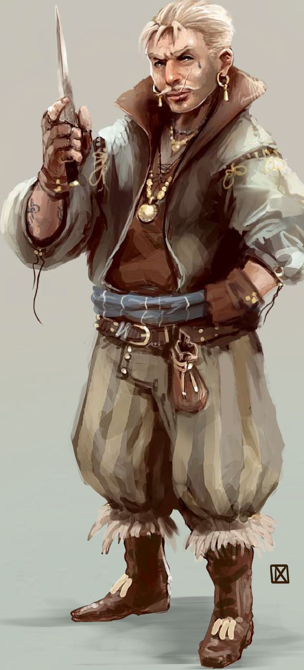

•17 B

Halruaa

The mageocracy has returned, but the last century has proven difficult for them. From rebuilding their homelands to exploring the new changes to Faerun, there's a lot of work ahead for the city of mages.

Empower Magical Items

Using your own arcane talents, magic items are empowered when used by you.

**Prerequisites:** You possess spellcasting slots.

When using magic items, you gain the following benefits:

* If an item has a listed save DC, you may use a bonus action to replace it with your own spell save DC.
* Whenever an item in your possession regains charges, add one to the number of charges it regains (up to the regular maximum}
* If an item would break on a roll of 1 due to running out of charges, you have advantage on that roll

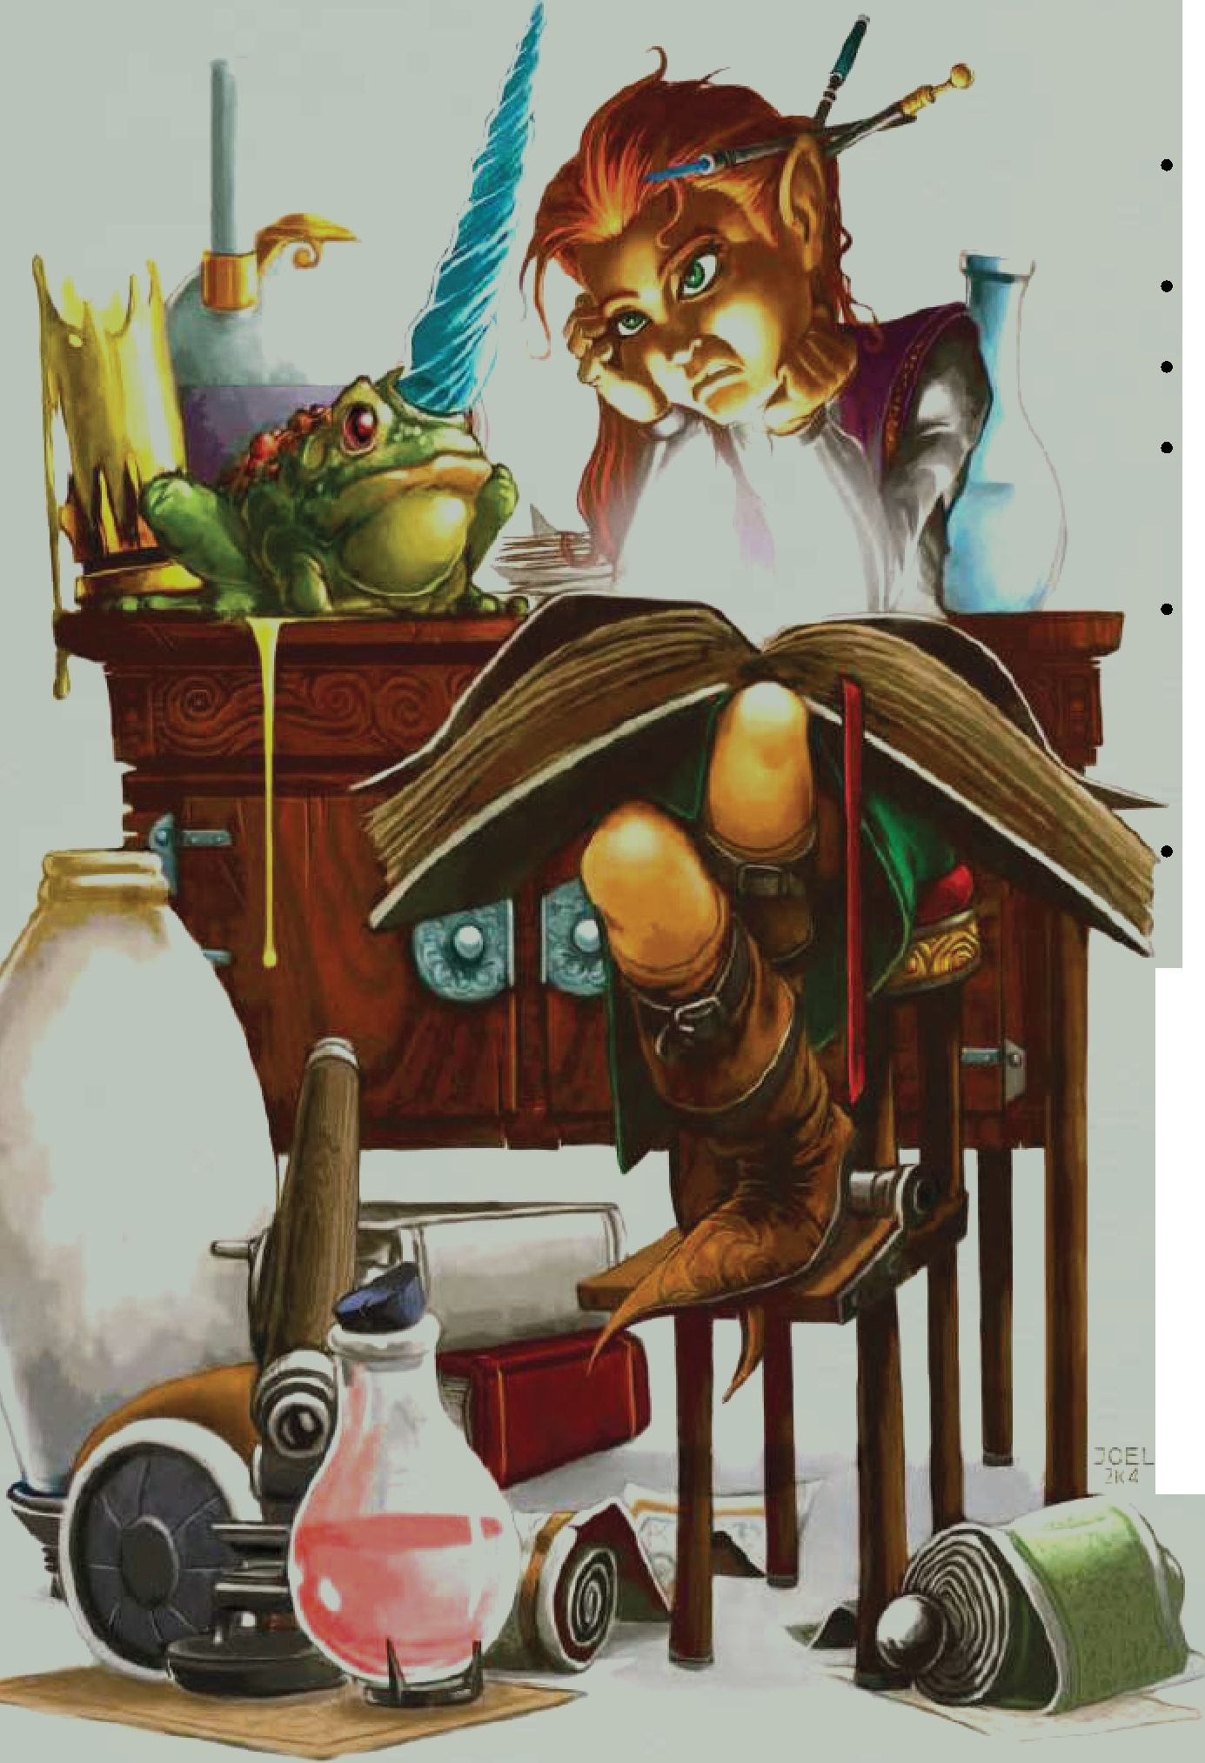

Arcane Additives

Halruaan's are some of the few wizards in all of Faerun to have unlocked the secret of slipping minor spells into greater ones.

**Prerequisites:** You possess spellcasting slots.

When a magic user other than yourself casts a 5th level or lower spell while within 10 feet of you, as a reaction you may add some of your own magic into the spell Expend a spell slot of a lower level than the one which trigged this ability.

Choose one of the following effects and add it to the casting of that spell You cannot choose an effect if you do not have a spell of the same school prepared (for example, if you have no evocation spells prepared, you cannot use the Evocation effect}

* **Abjuration:** The spell you are adding to counts as though it used a spell slot one level higher for the purposes of *Dispel Magic* or *Cotin terspell*
* **Evocation:** If the spell deals damage, one target takes an additional die of damage. If the spell does not use damage

dice, the target takes damage equal to your intelligence modifier instead. If the spell doesn't deal damage, your damage is applied first, before the effects of the spell take place.

**Transmutation:** If the spell requires concentration, when the caster loses concentration it lingers for one additional round.

**Divination:** If the spell requires a spell attack roll, the caster has advantage on the roll

**Enchantment:** If the spell requires a saving throw, one target has disadvantage on this saving throw.

**Illusion:** You appear to be the caster of the spell If a creature tries to use *Cotinterspell,* instead they counter this effect (additional creatures may still counter the original spell}

**Necromancy:** If the spell kills any creatures that are valid targets for the *Animate Dead* spell their corpse is defiled and a skeleton or zombie gets up in their space under your control This creature takes its turns after yours, and disintegrates after a number of rounds equal to your proficiency modifier.

**Conjuration:** If the spell teleports targets, any teleported creatures can choose to have themselves teleported up to 5 x your intelligence modifier in feet away from the destination.

You can use this ability a number of times equal to your Intelligence modifier (minimum 1} Whenever you complete a long rest, you regain all uses of this ability.

This feat cannot be used on spells that are cast using spell slots above their regular level, nor can it be used on spells cast as rituals or spells with casting times of 1 minute or longer.

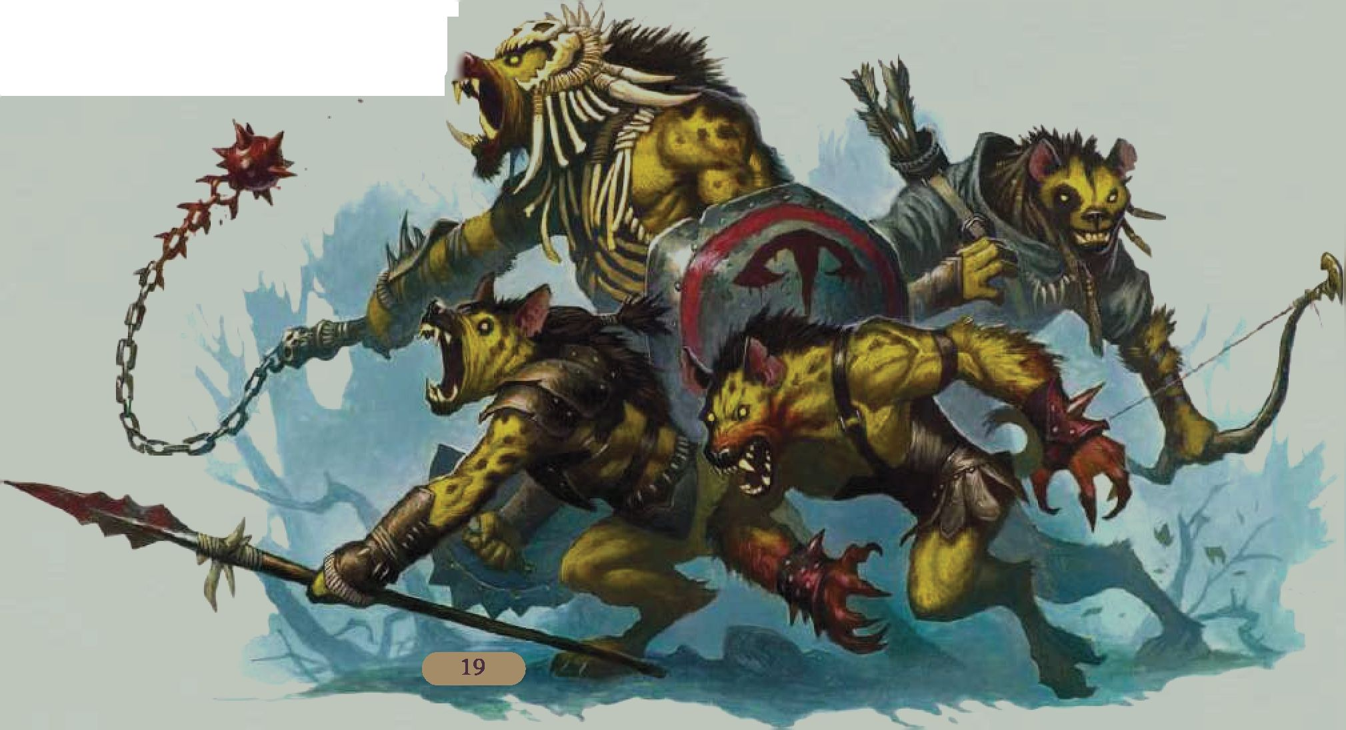

Collectively referring to Durpar, Estagund, and Var, these are fertile and prosperous lands inhabited by followers of the 'Adama" which is part philosophy and part religious practice. Var is now a desolate and empty region, having been flooded during the spellplague.

Follower of Adama

Dealing with so many different peoples and races, the merchants of durpar are second to none. Even magical coercion seems unable to find purchase thanks to their training with the Adama.

Increase your Wisdom score by 1, to a maximum of 20.

In addition, you gain the following benefits:

* You have advantage on checks made to buy or sell items.
* You always get a slightly better deal, allowing you to set aside a little extra. Your lifestyle costs are halved.
* If you succeed on a saving throw that would cause you to become Charmed or Frightened, choose another creature who also had to save against the same effect. They automatically succeed on their saving throw.

Lurien

The monsters of the wilds surrounding Estagund have formed into a variety of beast-tribes, all of which have their own cultures and traditions.

Territorial Markings

Understanding your neighbors is important, especially when they might be a dragon or vampire.

Increase your Intelligence score by 1, to a maximum of 20. You gain the following benefits:

* If you spend 1 minute looking at evidence of a monster (tracks, scent, droppings, or any other physical evidence) you can identify that creature type and size category.
* If you spend at least 10 minutes looking at the same evidence, you can determine how long ago the creature was present and if their CR is greater or less than your level
* You are aware whenever you enter a region affected by lair effects, as well as the direction of the center of that effect.
* If you spend a short or long rest, you can obscure your camp from a type of monster. Choose one type of monster. Creatures of that type have disadvantage on all checks made to find you or anyone else in your camp.

The homelands of all halflings, Luiren was once thought lost. It's been discovered that the halflings who lived there learned how to survive on island redoubts.

Master Chef

Halflings are famed for their appetites, and their cooking skills are renowned all across Toril

Increase your Constitution score by 1, to a maximum of 20.

In addition, you gain the following benefits:

You gain proficiency with cook’s utensils. If you’re already proficient with them, your proficiency bonus is doubled for any ability check you make with them.

You have advantage on checks made to determine whether food or drink is poisoned. If you imbibe poisoned food or drink, you automatically know if it was poisoned.

As part of a long rest, you may prepare meals for your group. Anyone who eats your meal during the long rest

recovers a number of additional hit dice equal to your

proficiency bonus, in addition to the regular amount of half their hit dice. Any companions who already have their maximum hit dice instead gain temporaiy hit points g equal to your level *

Appendix **A:** Creatures

Varm Elemental

*Tiny elemental, neutral*

|  |  |  |  |
| --- | --- | --- | --- |
| **Armor Class** 1 3 (Natural Armor) | |  |  |
| **Hit Points** 5 (2d4)  **Speed** 20 ft., fly 40 ft. |  |  |  |
| **STR DEX CON** | **INT** | **WIS** | **CHA** |
| 4 (-3) 1 5 (+2) 11 (+0) | 10 (+0) | 10 (+0) | 7 (-2) |

**Damage Immunities** Poison

**Condition Immunities** Charmed, Poisoned

**Senses** Darkvision 60 ft., passive Perception 10 **Languages** Auran (air), Aquan (water), Ignan (fire),

Terran (earth)

**Challenge** 0 (10 XP)

**Telepathic Bond.** While the elemental is on the same plane of existence as its summoner, it can magically convey what it senses to the summoner, and the two can communicate telepathically.

Action s

**Slam. (air)** *Melee Weapon Attack:* +4 to hit, reach 5 ft., one creature. *Hit:* : 1 d4 thunder damage. The target must succeed on a constitution saving throw (DC 1 0) or be deafened until the end of their next turn

**Slam. (earth)** *Melee Weapon Attack:* +4 to hit, reach 5 ft., one creature. *Hit:* : 1d4 bludgeoning damage. The target must succeed on a strength saving throw (DC 10) or be knocked down.

**Slam. (fire)** *Melee Weapon Attack:* +4 to hit, reach 5 ft., one creature. *Hit:* 1 d4 fire damage. The target must succeed on a dexterity saving throw (DC 10) or ignite if they are flammable. A creature that is on fire takes 1 d4 fire damage at the start of each of their turns, until they use their action to put the flames out.

**Slam. (water)** *Melee Weapon Attack:* +4 to hit, reach 5 ft., one creature. *Hit:* : 1d4 cold damage. The target must succeed on a constitution saving throw (DC 10) or have their speed halved until the end of their next turn.

Loyal Band

Below are the pages where you can find the stat blocks for your followers. SRD is the system reference document. It and the Basic Rules are both freely available from Wizards of the Coast, on their website.

**Regular Followers**

|  |  |  |  |
| --- | --- | --- | --- |
| **Creature** | **SRD** | **Basic Rules** | **Monster Manual** |
| Bandit | 396 | 162 | 343 |
| Cultist | 398 | 163 | 345 |
| Guard | 399 | 163 | 347 |

**Special Followers**

|  |  |  |  |
| --- | --- | --- | --- |
| **Creature** | **SRD** | **Basic Rules** | **Monster Manual** |
| Acolyte | 395 | 162 | 342 |
| Scout | 401 | xx | 349 |
| Thug | 402 | 164 | 340 |
| Bandit Captain | 397 | xx | 344 |
| Cult Fanatic | 398 | xx | 345 |
| Spy | 402 | xx | 349 |
| Priest | 401 | 164 | 348 |
| Veteran | 403 | xx | 340 |

**Substitution** As we can only want to cover what will be available to most players, the loyal band feat only looks at creatures from the Monster Manual.

If your DM allows, our guideline is that a regular follower is CR 0 or CR 1 /8.

A special follower is decided by level: CR 1 /4 or CR 1 /2 if your level is between 5 and 9. CR 1 and CR 2 if your level is between 10 and 1 5. And CR 3 if your level is 16 or above.

F

Appendix **B:** Arcane Assistant

Arcane Assistant

The arcane assistant functions as the *Unseen Servant spell* below, with the following modifications:

* The AC of the servant is equal to 8 + your proficiency modifier.
* The Strength score of the servant is equal to your proficiency modifier for the purposes of lifting and dragging objects.
* Your servant can cast *Mending* and *Prestidigitation* as an action, when directed
* The spell ends if the servant moves more than 60 feet away from where it was cast. The spell does not end if the servant is more than 60 feet from you.

Unseen Servant

*1st level conjuration (ritual)*

**Casting Time:** 1 action

**Range: 60 feet**

**Components:** V **S M** (A piece of string and a bit of wood) **Duration:** 1 hour

**Classes:** Bard Warlock, Wizard

This spell creates an invisible, mindless, shapeless force that performs simple tasks at your command until the spell ends. The servant springs into existence in an unoccupied space on the ground within range. It has AC 10,1 hit point, and a Strength of 2, and it can’t attack. If it drops to 0 hit points, the spell ends.

Once on each of your turns as a bonus action, you can mentally command the servant to move up to 15 feet and interact with an object. The servant can perform simple tasks that a human servant could do, such as fetching things, cleaning, mending, folding clothes, lighting fires, serving food and pouring wine. Once you give the command the servant performs the task to the best of its ability until it completes the task, then waits for your next command

If you command the servant to perform a task that would move it more than 60 feet away from you, the spell ends.

Mending

cantrip transmutation

**Casting Time:** 1 minute

**Range:** Touch **Components:** V **S M** (Two lodestones) **Duration:** Instantaneous

**Classes:** Bard Cleric, Druid Sorcerer, Wizard

This spell repairs a single break or tear in an object you touch, such as a broken chain link, two halves of a broken key, a tom cloak, or a leaking wineskin. As long as the break or tear is no larger than 1 foot in any dimension, you mend it, leaving no trace of the former damage.

This spell can physically repair a magic item or construct, but the spell can’t restore magic to such an object.

Prestidigitation

*cantrip transmutation*

**Casting Time:** 1 action

**Range:** 10 feet

**Components: V S**

**Duration:** Up to 1 hour

**Classes:** Bard Sorcerer, Warlock, Wizard

This spell is a minor magical trick that novice spellcasters use for practice. You create one of the following magical effects within range:

You create an instantaneous, harmless sensory effect, such as a shower of sparks, a puff of wind faint musical notes, or an odd odor.

You instantaneously light or snuff out a candle, a torch, or a small campfire.

You instantaneously clean or soil an object no larger than 1 cubic foot.

You chill, warm, or flavor up to 1 cubic foot of nonliving material for 1 hour.

You make a color, a small mark, or a symbol appear on an object or a surface for 1 hour.

You create a nonmagical trinket or an illusory image that can fit in your hand and that lasts until the end of your next turn.

If you cast this spell multiple times, you can have up to three of its non-instantaneous effects active at a time, and you can dismiss such an effect as an action.

fl21 B

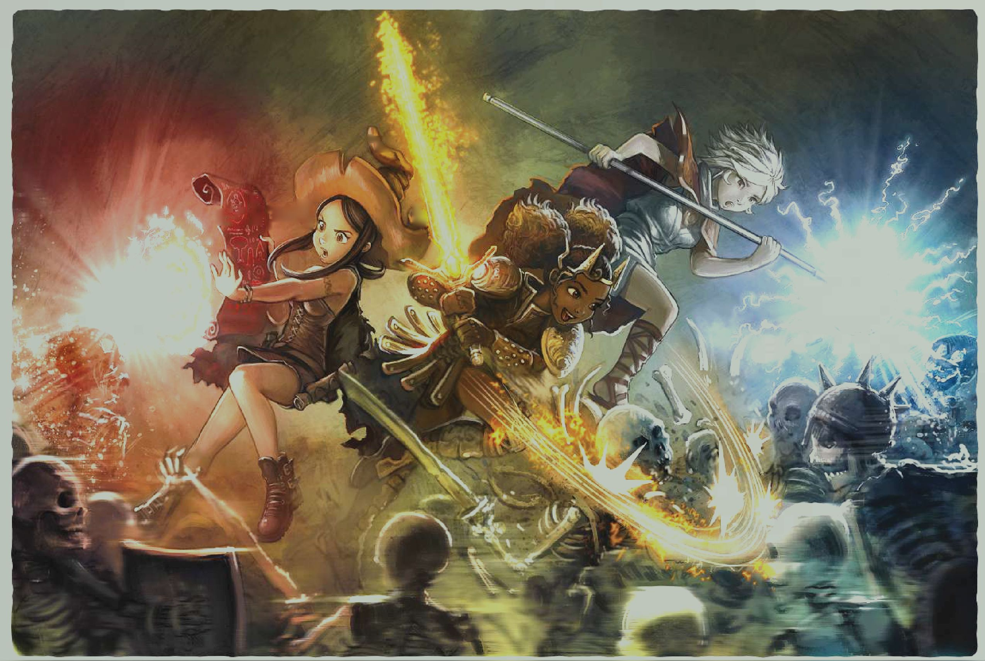

|  |  |  |
| --- | --- | --- |
| v *V *5 I | | |
|  |  | - I |

|  |  |  |  |  |
| --- | --- | --- | --- | --- |
| V” ■ |  |  |  |  |
| r'’1' V ]b^ |  | 1 |  |  |
|  |  |  |  |  |

On The Cover

Pepper and her friends imagine themselves in a world of high fantasy and make believe, taking a break from their rather boring magical studies.

The image is used with permission from the artist David Revoy, from the webcomic "Pepper and Carrot". This fully open sourced web comic is available for free. It is created with open sourced software, released under an open source license, and the author fully encourages others to use and reuse the work done on Pepper and Carrot in new ways.

Pepper and Carrot can be found at <https://www.peppercarrot.com/>

Endless Opportunity Awaits

The folks of the Forgotten Realms are varied and diverse, there's no reason your character should be any different.

Inside you'll find 5 5 feats, each representing a different culture. These feats are balanced across the three pillars of play, and present different approaches to combat, exploration, and social encounters.

